CURRICULUM VITAE

NAME : GBENGA SAMSON OMOWU
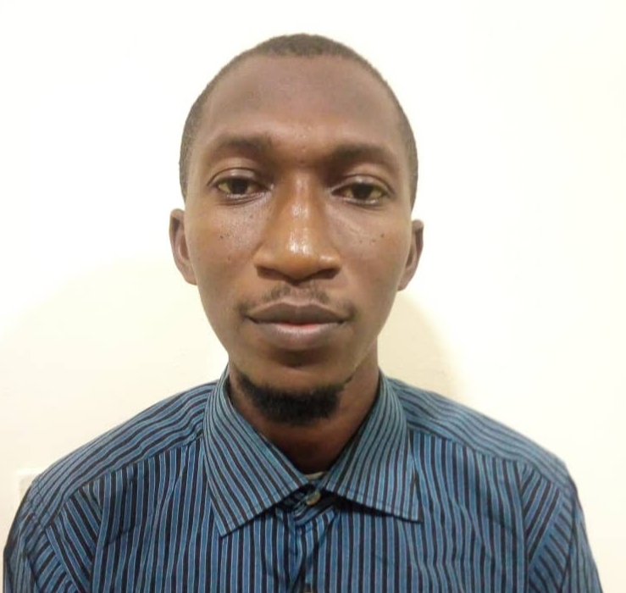
DATE OF BIRTH: 25/MAY/1989
PASSPORT NO: B00173702
MOBILE NO: +971553694156
GENDER: MALE
MARITAL STATUS: SINGLE
NATIONALITY: NIGERIA
VISA STATUS: VISIT VISA
EMAIL ADDRESS: omowugbeng@gmail.COM
HOUSE ADDRESS: Hamdan Street, Abu Dhabi, UAE

PERSONAL PROFILE
I am a Consistent, Hardworking and Highly motivated person seeking to Learn, utilize my skills and gain further experience in an Environment that will challenge me further, while allowing me to contribute to the continued growth and success of the organization.

POSITION DESIRED: Chemical Engineering Trainee/ Maintenance
CAREER HISTORY
SKILLS
- Ability to utilize interpersonal skills that contribute to a strong team environment.
- Assessing risk and possible safety hazards
- Ability to perform/ fix lighting, Electrical appliances and take/ read temperature, relative humidity etc
- Strong planning and organizational skills with sense of priority for deadlines and attention to details
- Physical strength, trunk strength and ability to lift and move heavy objects
- Ability to multitask, work in a fast paced environment and have a high level attention to detail
- Ability to work independently with minimum supervision

COMPUTER SKILLS
MS office such as word, excel
Engineering software such as AutoCAD, CHEMCAD, HYSYS etc.
Graphics design.

EXPERIENCE
May 2015 -Aug 2017: Luco Scientific Limited, Edo- Nigeria
Position-Laboratory assistance and Maintenance
Duty: Assist and set up equipment for experiment in the lab using PPE and also fixed some electrical appliances in laboratory

March 2017-Feb 2018: Falcon Chemicals, Ogun- Nigeria
Position- Laboratory technician and Quality control Officer
Duty: Worked in the physical organic Chemistry laboratory (Quality control), to ensure that a manufacture product is in accordance with the standard value observing HSE protocols

ACADEMIC QUALIFICATIONS
- University of Benin, Edo State, Nigeria
Bachelor of Engineering, Chemical Engineering (Second Class Upper)
2014- 2019
- University Of Benin, Edo State, Nigeria
Diploma in Chemical Engineering (Credit)
2012-2014
- Christ Academy High School, Ikotun, Lagos- Nigeria
Senior Secondary Certificate Examination
2001- 2006
- Local Government Primary School, Idimu, Lagos- Nigeria
Primary School Leaving Certificate
1995-2001
REFERENCES
- Mr Lukmon
Store keeper
Dubai, UAE.
+971556045378

- Engr O. Osewinge
Senior Lecturer
Department of Chemical Engineering, University of Benin,
Edo- Nigeria.
+2347032213827.

