NYEROVWO ADAMS

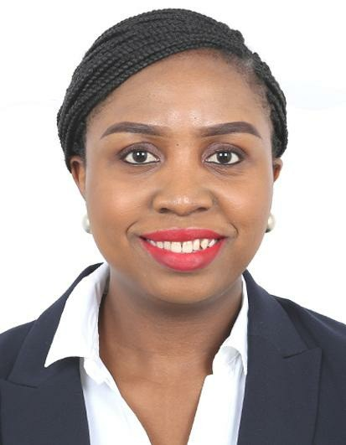
WORK EXPERIENCE

 Dubai, United Arab Emirates Visa Status - Residence

 +971524015995

neroobire@gmail.com

CORE COMPETENCIES:
Tele Sales Executive Customer Service
Sales Associate

PERSONAL SUMMARY:
An effective, efficient and dependable individual with growing experience in provision of hospitality solution and leadership at different levels.
Possesses excellent interpersonal, communication, presentation, negotiation and analytical skills and the ability to develop and maintain valuable relationships within and outside the organization to deliver excellent solutions.

Sept 2017 - Current
Volunteer Service
AL NOOR CENTRE FOR CHILDREN WITH SPECIAL NEEDS (Dubai,
The United Arab Emirates)
Helping individuals with special needs achieve their highest potentials. Assisting children with school activities
Collaborate with the classroom teacher to define appropriate activities for the pupils in about the curriculum.

March 2017 -
May 2020

Tele Sales Executive / Marketing
PRIME CONNECT EXHIBITION ORGANIZERS (Dubai, United Arab
Emirates)
Executed tasks such as cold calling, Prospecting and marketing Trade exhibitions
Making B2B outbound telesales calls
Selling exhibition space and stands to both new and existing clients.

Dec 2014 - Jan Sales Associate

2017
JOLOMI ENGINEERING SERVICE (Delta State, Nigeria)
Identifying and establishing new business organizing sales visits
Greeting customers, responding to questions, improving engagement with merchandise and providing outstanding customer service.
Introducing promotions and opportunities to customers. Demonstrate the working of a product when required.
Provide information regarding each products and any discount offer associated with it.

Nov 2013 - Oct Teacher

2014
NATIONAL YOUTH SERVICE CORPS -NYSC (Edo State, Nigeria)
Taught Geography at Anglican Girls Grammar School, Benin Prepared lesson notes, administered classes, assessments and
examinations as well as marked scripts and entered scores into school record notes.
Organized mentorship sessions for students.

Nov 2008 -
Sept 2010
Front Desk Agent
TERRACE GREEN HOTEL & SUITES (Lagos State, Nigeria) Communicate with the booking, housekeeping and maintenance departments to ensure prompt responses to guests’ needs
Make reservations or appointments for guests
Answer guest calls and record complains for future follow-up
Meet and exceed guests’ expectations by anticipating the services they might require and suggesting local venues
Maintain constant communication with guests in advance of weddings, corporate retreats and other in-house events to ensure we’re prepared for them
Report any accidents or injuries to senior management staff immediately

EDUCATION

2010 - 2013 Bachelor of Science Geology and Petroleum Studies Western Delta University, Delta State , Nigeria

2007 - 2008 Diploma in Data Processing
University of Benin, Edo State, Nigeria.

2000 - 2005 West African Senior School Certificate Examination (WAEC) Creative Demonstration College, Delta State, Nigeria.

CERTIFICATIONS
SEPT - 2017 Certificate of Volunteer Interaction Programme
AL NOOR TRAING CENTRE FOR CHILDREN WITH SPECIAL NEEDS
Dubai, United Arab Emirates

2013 - 2014 Certificate Of National Service
NATIONAL YOUTH SERVICE CORPS, (NYSC)
Edo State, Nigeria

