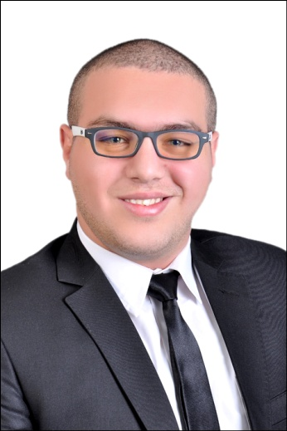
Mahmoud Ashraf Mahmoud
MahmoudAshraf3811@Gmail.com
Dubai-UAE
Cellular: +971 555 88 11 95
Objective  Work Experience  Job Description  Education  Certifications  Language skills  Interpersonal skills  Personal Information  Computer Skills  Availability |  |   I am an organized and driven sales leader professional with more than 6 years’ experience in Telecommunication Sales industry. Seeking an opportunity to use my team management skills as a Sales Manager in your fast-growing Company.  - Axiom Telecom , Du Franchise :    - Sales Team Leader from September 2019 till now.  - Vodafone Egypt :  - Sales advisor from Sept 2015.  - Team leader from Sept 2016 to April 2017.  - Store Manager for Multiple store from May 2017 September 2019.  Job Description As ASM At Vodafone Egypt :  - Maintaining awareness of market trends in the retail industry, understanding forthcoming customer initiatives and monitoring what local competitors are doing.  - Accountable for customer complaints and understanding on customer experience in each store through TNPS survey.  - Managing and motivating a team to increase sales and ensure efficiency and quality of sales for Store.  - Managing stock levels and making key decisions about stock control.  - Using information technology to record sales figures, for data analysis and forward planning.  - Dealing with staffing issues such as interviewing potential staff, conducting appraisals, Coaching and performance reviews.  - Providing or organizing training and development.  - Ensuring standards for quality, health and safety are met.  - Resolving health and safety, legal and security issues.  - Updating Team on business performance and other pertinent issues.  - Faculty of Law - Bachelor degree (Alexandria University).  - Grade: Good  - Retail vision Vodafone Way of Retail (Vodafone Egypt).  - Excellence customer Experience Training by Vodafone Egypt.  - DU Way Of Retail ( Du UAE ) .  - Arabic: Mother tongue.  - English: Very good.  - Problem solving and Work under pressure, Multi tasks, Teamwork player and body language.  - Research and Presentation skills and ability to make fast and reliable decisions about how to solve problems.  - Happy to take on plenty of responsibility.  - Effective leadership and the ability to motivate others.  - The ability to plan workloads and Delegate accordingly.  - Customer focus by deliver the best customer experience.  - Full Name: Mahmoud Ashraf Mahmoud.  - Date of Birth: 13/08/1991.  - Nationality: Egyptian.  - UAE Driving License : Available  - Professional at Siebel oracle system.  - Professional at CRM system.  - Professional at (Win Cash) Retail Cash Handling system.  - Professional at VAS Investigator system.          - Professional at Master Card Cash transfer over phone applications.  - Availability: Able To Start Work within 30 Days from Announcement.  - As: Full Time.

