Professional Courses &Certification:

- ITIL v3 Foundation certified
- Microsoft Certified Professional (MCP) Win 2008 Network Infra & Configuration
- MCP in Server Virtualization with Win2012 Server Hyper-V & Sys
- Cisco Network Associate Training
- Office 365: Plan for EXO and Skype for Business Online
- Azure Management Tools & Active Directory - Basics
- Alibaba Cloud Certification Operate and Manage Cloud Server
- AWS Solutions Architect (Associate) Certification Course

Education:
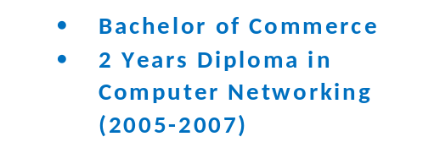
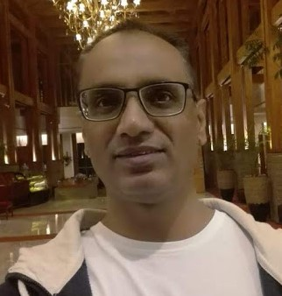
Muhammad Azam Khan
IT Services Delivery Professional

About Me
I have good communication and interpersonal skills, and the ability to work efficiently with all levels. I can provide technical support or services to users, analyze and understand their needs in order to faster the growth of the various sectors based on business objectives.

Address:
Flat # C-2, Rays Corner Block N, North Nazimabad, Karachi, Pakistan
Contact # +92-3028295699
Email : azkh_azmi@yahoo.com
- https://www.linkedin.com/in/muhammad-azam-khan-a8477322/

Soft Skills:
------------------
- Team Handling
- Customer Relationship Management
- Problem-solving and analytical skills
- Detail oriented and diligent
- Adaptability/Positive Attitude

Professional Skills:
--------------------------------
 O365 (EXO, OneDrive, Teams, Share point)
 Cisco (Router & Switches configuration, WebEx, Video Conferencing)


- Design and deployment of new IT Infrastructure and Services including exploring ERP Solutions, MS O365, Cloud Solutions
- Monitor performance of information technology systems to determine cost and productivity levels, and to make recommendations for improving the IT infrastructure
- Analyze business requirements by partnering with key stakeholders across the organization to develop solutions for IT needs
- Assess vendors and develop test strategies for new hardware and software
- Troubleshoot hardware and software issues related to internal IT
Experience- 2:

SS Team Lead- Pfizer Pakistan
Aug-2008-Nov-2020

- Work closely with APAC Site Services Managers in network operations review; services escalation, SLA performance reviews, services improvement plans to meet KPIs, etc.
- Worked with Regional and Local Project Teams on various projects like Cyber Security (ICS), DI Tool Deployment, Network Revamp, Windows Migration, 600 iPad deployment with App management.
- Manage a team of local helpdesk engineers for IT Operations
- Provide desktop, laptop, network, application hosting services support (like Active Directory, Messaging, Audio/Video Conferencing etc)
- Owner of the Incident, Change and Configuration Management to the local infrastructure in accordance to global process and solutions
- Responsible for ensuring that all deliveries are meeting the agreed SLA including driving and mentoring Improvement Projects like call Reduction, First Call Resolution Rate, Asset Management etc..

Associate Manager IT
Hi-Tech Foods Pvt Ltd
May 2021-todate

Experience- 1:

Continue on page 2

Experience-3:

Data Center Administrator Nov-2007-July 2008- Pfizer

- Managed HP ProLiant ML/DL Series servers, OS Win 2008/2012.
- Managed Cisco 1800 series routers and Catalyst switches within Pfizer Head Office and other sites like Islamabad, Lahore, Multan, Peshawar
- Monitored network performance and utilization via network tools like SolarWinds, MRTG etc...
- Setup Video Conferencing through IP/ISDN lines between Pfizer Sites.
- Configured company profile on Android, iPhone/iPad and resolved issues.
- Oversees troubleshooting, systems backup, and disaster recovery (RDP)

Experience-4:

ServiceDesk Support Engineer Feb-2007-Oct-2007- Pfizer

- Act as a 1st Line Support Engineer with clients and help to resolve their issues in timely manner
- Escalated issues with other Level2/Level3 support teams to apply best ITIL practices
- Assists team members as needed
- Support the software/hardware technologies like MS office 2003-2010, Windows XP/Win 8, Lenovo/HP desktops, laptops, printers and scanner.

Experience-5:

Network Support Engineer Dec-2000 to Jan-2007-Fascom Systems

- Act as a 1st Line Support Engineer with clients and help to resolve their issues in timely manner
- Assist Field Engineers in installation and configuration of proxy and mail server like ISA, MDaemon, I Mail
- Configured and maintained WAN Links (DXX, ISDN, Broadband) point to point and multipoint connections
- Customer support and resolve internet connectivity issues

References:

- Yogesh Nerurkar - Program Manager at DXC Technology -Mumbai India. Contact # +91 75069 27040, +91 98190 14362

- Waseem A Khan - Section Head IT at Pak Arab Refinery Ltd, Karachi Pakistan. Contact # +92 30 2017513

Projects Coordination:
==================
- 2019-2020: DI tool (Deskman) deployment, configuration, administration on quality operations systems at Pfizer Plant as a part of Cyber Security program.

- 2019 Worked with local & regional project teams for ICS Cyber Security Program at Pfizer PGS Plant in April 2019.

- 2016-2017 Worked as a project coordinator with Regional Network team in Network Revamp Project in Pfizer Pakistan. Replacement of all network devices with new and upgraded devices at PGS Plant.

- 2016 - Actively engaged in Mobile Device (iPad) Deployment for Pfizer Field Force create and configured MDM, Apple ID, Pfizer apps on more than 200 iPads for phase one.

- 2014-2015 - Provided support as a Project Coordinator to Pfizer APAC team to Windows Migration project more than 900 laptops and desktops all over Pfizer Pakistan offices

- 2008 - Assist Desktop Support during (DMS) project implementation in Pfizer Pakistan

- 2008 - Assist BTI Team for all infrastructure documentation and knowledge transfer during HP transition, create RFCs and implementation.

- 2007 - Assist Pfizer Corporate and Local CIT Team on the following main projects in Pfizer Laboratories Pakistan
  - Metro Fiber Connectivity between Pfizer offices Karachi West Wharf to Karachi SITE
  - Fiber Connectivity between Karachi SITE to Islamabad offices
  - Pfizer Pakistan WAN link shifting from IPVN to MPLS

Expertise
UI/UX
Photoshop
Illustrator
HTML
CSS

