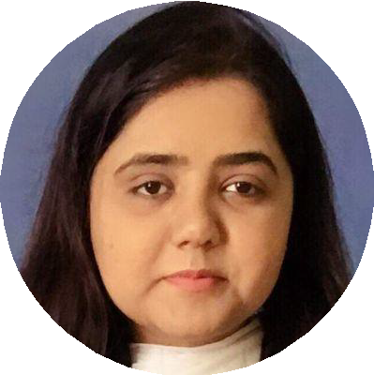
Rida Amna
HR Professional

Experienced HR Professional with a demonstrated history of working in the human resources industry. Skilled in mental health, and teaching. Strong human resource services professional with a Master of Philosophy - focused in industrial/Organizational Psychology.

HR Professional

Experienced HR Professional with a demonstrated history of working in the human resources industry. Skilled in mental health, and teaching. Strong human resource services professional with a Master of Philosophy - focused in Industrial/Organizational Psychology.

ridaamna41@gmail.com

+971 - 54 3125042
AL Jurf 3, Ajman, United Arab Emirates
https://www.linkedin.com/in/rida-amna-3a047394/

SKILLS
Presentation
Team management
MS oﬃce
Psychometric testing
Online marketing
Leadership

LANGUAGES

Urdu
Bilingual Proﬁciency

English
Professional Proﬁciency

INTERESTS

Travelling
Volunteer work
Reading

WORK EXPERIENCE

HR Recruiter
Water Seal group of companies
06/2021 – Present Sharjah, United Arab Emirates

- Conducted online/physical interviews for different departments such as engineering, purchase, accounts, sales, construction, water proofing, Interior, metallic.

- Assessing and Evaluating Candidates and Scheduling and Conducting interviews.

- Conducting exit interviews of employee.

- Demonstrate and Monitors On-boarding and Off-boarding of employee.

- Planning of employee induction with each branch manager to ensure that the new joiners are familiar with the work environment and keeping records of induction and joining reports

- Facilitating in employment visa applications for new employees and monitoring visa renewal for existing employee.

- Coordinating with PRO for all the Visa related work and ensuring to be in a timely manner.

- Handling and responsible for Leaves Management.

- Handling Medical Insurance Application for staff.

- Maintain and control over personal files of the employee.

- Acting as the first point of contact for any Human Resources issues such as grievance, emergency situations and other related matters.

- Dealing with recruitment of labors inside and outside the country.

- managing social media accounts for job postings

HR Recruiter
Mint International Overseas Promoter
01/2016 - Project based Karachi, Pakistan
- Effectively Recruited manpower for different companies in the Middle East.

- Managed to reduce the recruitment time from 60 days to 40 days per assignment.

- Planned, organized and executed hiring events partnering with community organizations; facilitated and delivered presentations.

- Managed hiring and communication across 10 client and 20 roles during my tenure.

- Managed and administered pre-employment assessment to prospective candidates.

- Wrote employee manual covering company policies, disciplinary procedures, code of conduct, FMLA policy and benefits information.

Counselor/Recruiter
Army Public School
09/2017 - 09/2018 Karachi, Pakistan
- Introduced training sessions for staff and students to cope up with the work and exam stress.

- Introduced and implemented mental health week for students and parents.

- Helped to ensure employee retention by working to understand the desires and needs of employees.

- Introduced career counseling sessions for students and parents which led to help them chose their subjects wisely.

- Introduced and implemented various policies for staff and students leading to an increase in student performance and staff being more efficient.

Accessor
Institute of Professional Psychology (IPP) and Galivco Bahria University Karachi Campus (BUKC)
12/2017 - 01/2018 Karachi - Pakistan
- Designed and directed assessment center in different cities of Pakistan for one of the leading gas company SSGC.

- Successfully executed psychometric testing.

Intern
Prime HR
09/2018 - 12/2018 Karachi - Pakistan
- Conducted interviews, managed candidates proﬁles for different clients.

- Designed and executed various HR Policies for different clients.

EDUCATION
Master of Philosophy - Organizational Psychology

Bahria University
09/2017 - 01/2020 Karachi, Pakistan

Bachelor of Science Degree, Professional Psychology
Bahria University
09/2012 - 01/2017 Karachi, Pakistan

Bachelor of Science
Karachi University
12/2009 - 06/2012 Karachi - Pakistan

