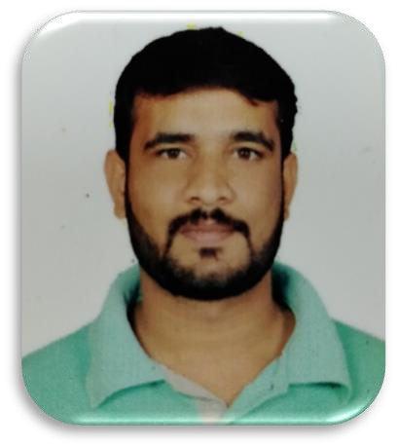
 |  | OBJECTIVE
 |  | I am currently looking for a full time position in an environment that offers a greater challenge, increased benefits for my family, and the opportunity to help the company advance efficiently and productively.
 |  | WORK EXPERIENCE
Mohammed  Ismail Khan  EDUCATION  Bachelor of Commerce. (Discontinue). JOC in Basic Electronics Communication Government Polytechnic.  ABOUT  Address: #19 Saarika 4th Cross Vaderahalli Lakshmipura cross Bangalore -560097  Marital status: Married.  PHONE:  +91 98803500397  EMAIL:  ismail.khan079@gmail.com |  | - Total Years of Experience: 19 years  - EIFMS PVT LTD as General Manager for NIKKO 2 Apartment Bharatiya city – still working  Mahaleela Solutions Pvt Ltd  - May 2021 to November 2022  - Managed Business operations of workplace.  - Managing day to day Facilities of the Office premises  - Taking care of Whole South India Operations with respect to Facilities & Business  - Established process/Operations/cost modifications ensuring business continuity  - Managed Employee services, Engineering, HSE, Transformation etc.  - Governed operational & financial aspects of IFM for South Region  - Managed successful project takeover  - Introduced annual day concept for support staff encouraging team bonding, integrity & collaboration.  - Setting up new offices as per the process requirements  - Closely working with MD for Business requirements & acquiring New Business partners  Golden Star Facilities and services  - Senior Operation Manager Aug 2018 to May-2021  - In charge of the shift, ensuring 100% upkeep of the facility, Handling and resolving client complaints regarding Daily House Keeping issues service problems  - Completing Daily & Weekly reports as necessary and updating them in the MOM  - Identifying, escalating priority issues and reporting to the high-level management  - Other duties as assigned  JLL -Concentrix– Operations Manager for South  Jan 1st, 2014 TO May 18- 2017  - Work closely with the team, motivating and coaching them  - Hosting 1-2-1’s and team meetings  - Keeping up to date with business development and innovation lines  - Handling Client Service Management  - Manage day-to-day line activities, priorities and make risk/impact assessments within existing processes and towards achieving SLAs  - Ensure training and development plans are maintained for all team members  - Support the Operations Team to highlight operational risks and areas for improvement  - Keep up to date with any changes affecting the business and relaying this knowledge back to the team  - Coordinating with Building Property Management team to ensure the functionality of HT/LT Panels, DG sets, Main Feeders, chillers, Common area cleanliness, Common area  lighting, Fire Fighting systems, Vehicle parking issues if any.  • Escalate any appropriate problems to senior management  • Support the Senior Manager to highlight operational risks and areas for improvement  Randstad IBM Daksh – Soft Services Executive 2010–2011  - In charge of the shift, ensuring 100% upkeep of the facility.  - Briefing the HK Staff, Office Boys, Helpdesk Executive & M& E staff about the daily work schedule on shift basis.  - Closely monitoring the house keeping Activities as per the schedule.  - Checking manpower availability of H/K & M&E team as per agreement if any shortage needs to be informing agency to arrange the same with in time.  - Ensure the upkeep of Conference room, training room and meeting room in respect of H/K cleaning, markers, availability of chairs & tables & functional of all AV equipment’s.  - Ensure the functionality of Lighting, AHU, UPS system, PA system, Fire alarm system, Rest room Ac like sensors-based wash basin, Auto flush urinals, Exhaust fans etc.  - Coordinating with Building Property Management team to ensure the functionality of HT/LT Panels, DG sets, Main Feeders, chillers, Common area cleanliness, Common area lighting, Fire Fighting systems, Vehicle parking issues if any.

SKILLS
PERSONAL SKILLS:-
- Training and presentation skills
- Leadership and management skills
- Coaching and soft skills
- Self-motivated
- Ability to work under pressure
- Ability to work well with levels of management and personnel
- Ability to work individually, and as an effective team member
- Excellent communication skills
- Highly determined & focused

COMPUTER SKILLS:-
- Internet, Lotus mail, Office 365 & Zimbra Ability to interact with both software and hardware problems, and fix them.
- Social media & Digital marketing (Facebook, Twitter, Instagram, Snapchat, live
- Apps, etc.)
- Ability to use all internet tools (browsing, surfing, emailing, etc.).
- Proficiency in using MS Office (word, excel, power point, outlook).
- Ability to interact with Database systems.

LANGUAGES:-
- English: Excellent
- Kannada: Good
- Hindi : Good
- Telugu : Good
- Urdu: Good
Square Feet Handling details-

MTP Bangalore- 225762Sqft- PTP Bangalore– 60170Sqft Karle Bangalore – 131415Sqft- SRKVizag-40450Sqft
RG Vizag – 35000Sqft - Annex Building – 65291Sqft Millennium Tower – 133104Sqft- Ecospace Minacs - 93338 Sqft

SAP -2363254.05 Sqft
NTT DATA – 54,603.37 Sqft

