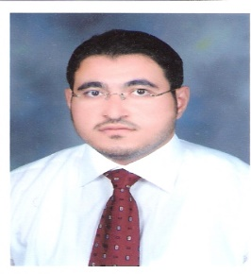
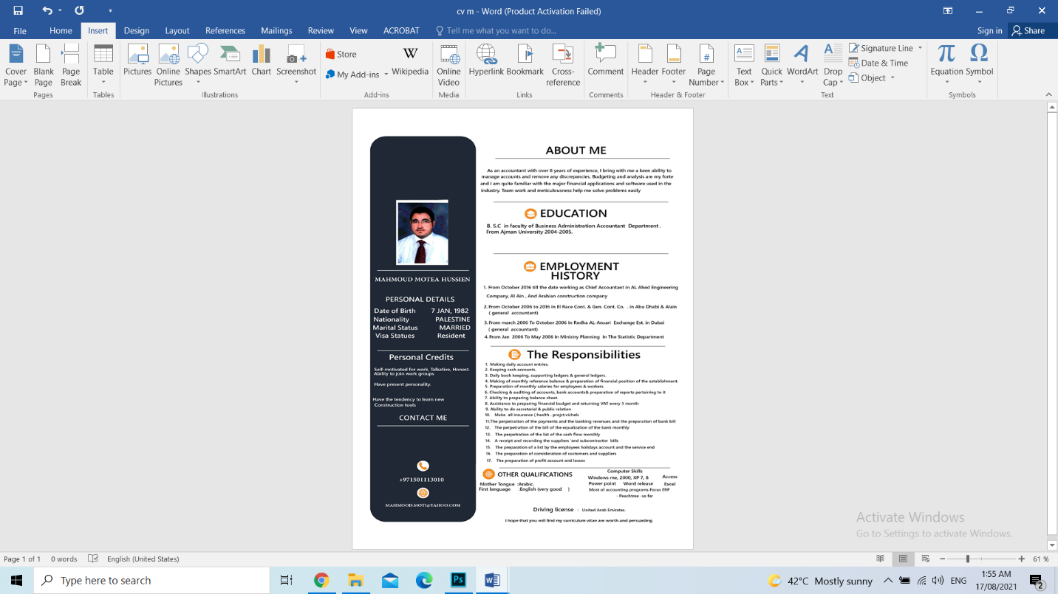
As an accountant with over 14 years of experience, I bring with me a keen ability to manage accounts and remove any discrepancies. Budgeting and analysis are my forte and I am quite familiar with the major financial applications and software used in the industry. Team work and meticulousness help me solve problems easily

ABOUT ME

DRIVING LICENSE UNITED ARAB EMIRATES
CONTACT ME
:+971501113010
MAHMOOD.MOTI@YAHOO.COM

I hope that you will find my curriculum vitae are worth and persuading.
MAHMOUD HUSSIEN

OTHER QUALIFICATIONS
Mother Tongue Arabic
First language English (very good)
Windows me, 2000, XP 7, 8 , Access , excel , Word release , power point
Most of accounting programs Focus ERP - Peachtree -so far

EMPLOYMENT HISTORY
THE RESPONSIBILITIES
- Making daily account entries.
- Keeping cash accounts.
- Daily book keeping, supporting ledgers & general ledgers.
- Making of monthly reference balance & preparation of financial position of the establishment.
- Preparation of monthly salaries for employees & workers.
- Checking & auditing of accounts, bank accounts& preparation of reports pertaining to it .
- Ability to preparing balance sheet.
- Assistance to preparing financial budget and returning VAT every 3 month.
- Ability to do secretarial & public relation
- Make all insurance ( health . projct.vichels )
- The perpetration of the payments and the banking revenues and the preparation of bank bill
- The perpetration of the bill of the equalization of the bank monthly
- The perpetration of the list of the cash flow monthly
- A receipt and recording the suppliers 'and subcontractor bills
- The preparation of a list by the employees holidays account and the service end
- The preparation of consideration of customers and suppliers
- The preparation of profit account and losses

- From July 6/7/2019 till the date working as Chief Accountant in prime engineering project
- From October 2016 till the date working as Chief Accountant in AL Ahed Engineering Company, Al Ain , And Arabian construction company
- From October 2006 to 2016 In El Race Cont. & Gen. Cont. Co. . in Abu Dhabi & Alain ( general accountant)
- From march 2006 To October 2006 In Redha AL-Ansari Exchange Est. in Dubai ( general accountant)
- From Jan 2006 To May 2006 In Ministry Planning In The Statistic Department

EDUCATION
B. S.C in faculty of Business Administration Accountant Department From Ajman University 2004-2005
Self-motivated for work, Talkative, Honest.
Ability to join work groups
Have the tendency to learn new

Personal details

Date of Birth 7 JAN, 1982

Nationality PALESTINE
Marital Status MARRIED
Visa Statues Resident
personal credits

MAHMOUD MOTEA HUSSIEN

