ASAAD HAMAIDA
Banking and Financial studies, Graduated from Emirates Institute for banking and Financial studies –UAE Abu Dhabi. (dated 2010) hired at Ajman Bank as DSA calling and convincing customers for buyout or fresh cases is one of my skills dated 17th Jan 2018 till date. Past experience was in First Gulf Bank (currently FAB) as CSO– serving customers in various branches and units dated 28th of July 2008 – on going currently . start up my career journey as call Centre agent (July 2008 – Nov 2011), where I build my general knowledge about bank products (liabilities and Assets ) and taking care of customer satisfaction. My next position was Retail service unit (complaint unit) from Nov 2011 – Dec 2013 where I learned how to resist customer anger and earned self-endurance skill. My Current position is Branch customer service officer & Sales Representative, where I gain customer trust by assisting in all services, Remittance and the main product by hitting my target by selling bank multi products like loan and credit cards. Holding this position since Dec 2013 till date. Moreover I am highly familiar in all departments operations related job like credit team and collections that add in my professional experience.

PASSPORT DETAILS:

PASSPORT NUMBER: P01931456
PLACE OF ISSUE: Abu Dhabi, United Arab Emirates
DATE OF ISSUE: 04 June 2015
DATE OF EXPIRY: 03 June 2020

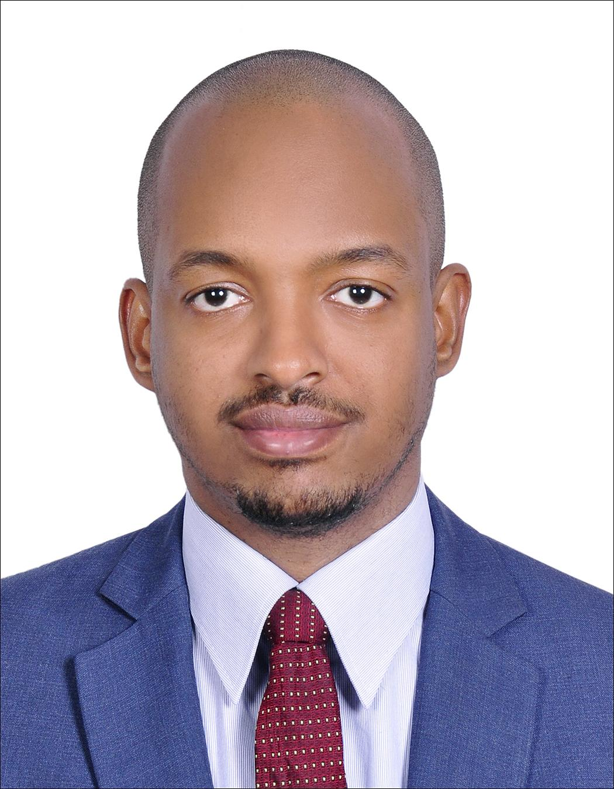

Asaad Hamaida
Abu Dhabi, United Arab Emirates
+971 55 1987994
asaadhamaidaa@gmail.com

Executive Summary

A professionally qualified banker with experience of over 11 years inside UAE in Direct Sales, Branch Customer Service, Operations, Retail Service Unit and in Call Centre.

OBJECTIVE

To seek better opportunity that will allow my capabilities in terms of bank Retail and operations field, executing excellence customer service, proper communication, analytical, and personal skills that a certain business needs to achieve while gaining knowledge in your organization that will allow me to further my career.

EDUCATION

2009 – 2010 Banking and Financial studies (Emirates Institute for Banking And Financial Studies)
Diploma of banking IFS
Murror Road, Abu Dhabi, UAE

2004-2005 Sheikh Khalifa Bin Zayed A. P.S School
Murror Road, Abu Dhabi, UAE

WORK EXPERIENCE

DUBAI ISLAMIC BANK

Joining Date: 29th July 2019 – on going

Worked as Direct Sales agent in credit card & personal Loan.

DUTIES

● assuring hitting the monthly target and crossing it.
● Maintain knowledge of competitors in credit card market.
● Contacting 100+ of existing and potential customer to ensure daily submission.
● provide accurate information for the clients in order to gain customer trust and his references in the near future.

AJMAN BANK

Joining Date: 17th Jan 2018 – Feb 2019
Worked as Direct Sales agent in personal finance mortgage & credit cards.
DUTIES
● As a key point of contact between an organization and the clients I should understand customers’ needs and queries then offering and advising accordingly.
● Maintain knowledge of current market, promotions and policies.
● Daily contacting and meeting customers to establish new potential business.
● Maintaining accurate information and records from the clients in order to submit my cases.
● Aiming to achieve monthly or annual targets.

FIRST GULF BANK
Joining Date: 28th July 2008 – 27th Dec 2017
Worked as call Centre agent, Retail service unit agent, and branch customer service.

DUTIES
Role Purpose & Key Priorities:
DUTIES:
- Main duty is to hit and cross my monthly target in sales (as DSA).
- Provide excellence customer service over 10 years’ experience working in a customer service sector I believe applying the same will be my demand.
- Main objective is provide customer service and resolving customer issues on spot
- Look to the case in different way in order to turn the complaints into opportunities
- Performing branch operational work on daily basis.
- Functioning daily branch reports
- To be In touch with all other department including (higher management, Retail credit, operations, sales, branches and collections) to build connection and to be well know about all policies and roles for other departments.
- Account opening/closing, (retail and SME) applying for statements, cheque books, all kind of bank letters such as liability, clearance, account confirmation, etc etc…
- Providing advises to customers how to manage their accounts and credit cards.

TASKS

- Daily Calling individual customers and listing companies.(as DSA)
- Meet customers, understand their needs and provide full services in additional to actively cross selling of products (Assets & liabilities) to new, existing and potential customers.
- Receive & processes customer request such as A/c opening cheque book request, debit card replacement, standing instructions, etc etc.
- Custodians of debit cards, credit cards, cheque books and E-dirhanms
- Educate customers about our automated channels like , ATM, mobile, call centre and online services.
- Meet target prescribed by management on monthly basis and building a bonded relationship with my customers.

ALLIED BANKING CORPORATION

- Money Laundering & Terrorist Financing Prevention (bank provide annual training since 2011)
- Compliance Awareness and Anti – Money Laundering (bank provide annual training since 2011)
- Orientation Program and Customer Service and branch related training.

PERSONAL BACKGROUND

Born on 19th July 1987 in Abu Dhabi, UAE. Can speak fluently in Arabic &. English Knowledgeable in Microsoft programs. Be able to work under pressure and willing to learn more about the job I am handling. Highly motivated, self – reliant employee and has a good rapport and team building skills. Supports best working relationship inside and outside the organization from different nationalities of all walks of life.

CHARACTER REFERENCES
Ajman Bank : Wael Nani 0502444059
First Abu Dhabi Bank: Abdul Salam Al Zubidi 0504912004

