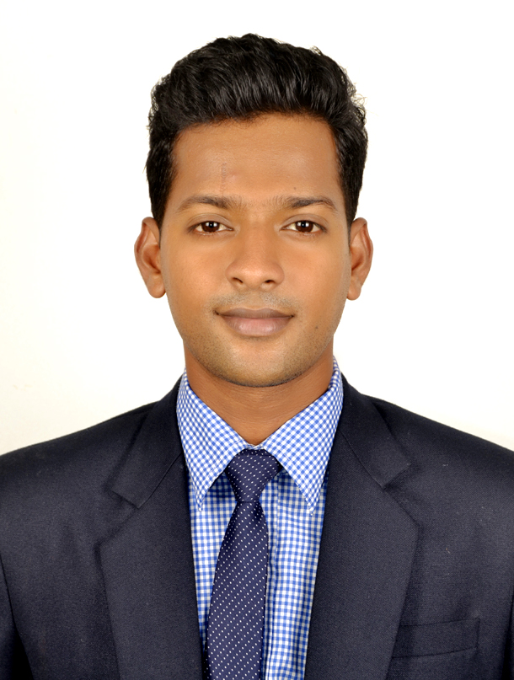

JIBIN JOSE
Dubai,UAE

Email: jibinstalin5@gmail.com

Contact no: +971-567058299

Current Address  Jibin Jose  One&Only Royal Mirage Hotel  P O BOX 37836  DUBAI,U.A.E  Permanent Address:,  Cherikkaparambil (H), Vaikom P.O, Kottayam  Pin 686141  Kerala, India  Personal Data:  DOB : 14-02-1994  Sex : Male  Nationality : Indian.  Marital Status : Single  Religion : Christian  Passport details  Passport No : P7317924  Date of Issue : 22-02-2017  Date of Expiry : 21-02-2027  Languages  Ability to effectively communicate in English Language.  Hobbies:  Swimming  Playing football  Travelling  Listening music | Personal profile statement  A hard-working, driven and motivated individual with extensive experience in providing hospitality services in domestic, care and commercial environments. I have the natural ability and the appropriate skills to work in customer-focused organisations with great enthusiasm and dedication. I am patient, understanding and flexible on the hours and shifts I work.  POST LOOKING FOR  Food and beverages service waiter.  WHAT AM I  Currently Working with One & Only Royal Mirage, Residence & Spa Hotel, Dubai as senior room attendant.  EDUCATION  - BSc. In Hospitality & Hotel Administration from IHM, Thiruvananthapuram, Kerala.  - Higher secondary in Science.  - S.S.L.C.  professional training and qualification  - Excellent interpersonal, customer service, time management skills, computer knowledge and MS Office.  - The ability to work under pressure and in a fast-paced environment.  - Dealing with stressful situations and remaining in control at all times .  - Punctual with excellent attendance record.  - Team leading ability.

Employment and Work Experience

One & Only Royal Mirage
Residence & Spa
Dubai
Joined as a room attendant.
Duration: 11-11-2017 to till date.
- Completed 6 month industrial training inVasundhara Sarovar Premiere Resort, Kerala.
- Volunteere for out door catering in various hotels such as Taj kovalam ,Leela kovalam, Muscat hotel Thiruvananthapuram.
- 2017 Nov 11th to present, One & Only Royal Mirage, Residence & Spa Hotel, Jumeirah Beach, Dubai (LHW Hotel) ,Working as Food and bevrage service associate.

Awards And Achievements

- Recognition by the Guest appreciations.
- Perfect Attendance for the year given by One & Only Royal Mirage,Dubai.
- Successfully completed Anti-Harassment and code of business conduct course.
- Successfully completed fire and safety training.

References

Name : Mr. Nidheesh
Position : Duty Manager
Address : One & Only Royal Mirage, Residence & Spa.
Tel : +971-501873645
Declaration

I, do hereby declare that the information given above is true to the best of my knowledge.
Place: DUBAI
Yours Sincerely
Jibin Jose

