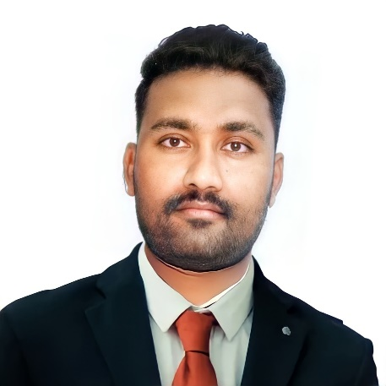 |  | EDUCATION  DR. B.R.AMBEDKAR UNIVERSITY FROM 2011 TO 2014 ( B.COM )  Khanapur (NIRMAL)  DHEEKSHA JUNIOR COLLEGE ( SCIENCE GROUP ) FROM 2009 TO 2011  Khanapur (NIRMAL)  SAI V N SECONDARY HIGH SCHOOL (2009)  KHANAPUR (NIRMAL)  WORK & EXPERIENCE  AL FUTTAIM 06/06/2021 [ PRESENT ]  Al Futtaim Group – Tashafi "(health hub)" GUEST RELATIONS EXECUTIVE" "PATIENT RELATIONS EXECUTIVE,(PRE)"  Handling cash and credit payment procedures and keeping  Client's personal data and information report problems daily and discrepancies to manager.  G4S Security services Aug 2019 to dec 2020  (HYD in)  Inspect and adjust security system, equipment and machinery to maximize coverage of parking lots and building interior and exterior.  Airport customer service agent MARCH 2017 TO MAY 2019 (In Dubai airports)  Greet the incoming passengers and help them throughout the boarding process.  Assisted customer on the front/ticketing counter, gate area or baggage service of office.  Transguard group L.L.C. (Under Emirates group}. DEC 2014 TO MARCH 2017  Office Admin Assistant  - Usage of ULTRAMAIN (computerized inventory system) updating and posting stock information.  - Answered calls and scheduled appointments.  - Greeted visitors with a friendly and helpful attitude.  - Provided interested parties with general information.  - Update daily SOR (Store outwards register)  personal details  Name: Shiva Kumar soma  D.O.B: 10/06/1992  Nationality: Indian  Marriage: Single  Linguistic capabilities: English and Hindi, Telugu (Read write)  Visa status: Two years employment (till date: 2023/02/27)  Certificate: Experience Certificate from T  Transguard Group L.L.C  SINCERELY  SHIVA KUMAR  Thanks.
SHIVA KUMAR SOMA

CONTACT
PHONE:
0527416756

EMAIL:
Shivakumarsoma3@gmail.com

OBJECTIVE

To utilize my technical skills and provide a professional service to customers by applying and honing my knowledge and working in a challenging and motivating working environment. i would love to do Challenging job with a rapidly growing organization, My goal in the future is to be able to solve complex problems as fast as humanly possible.

PROFESSIONAL SKILLS
Microsoft Office (Word, Excel, Power Point)

HIGHLIGHTS

- Able to thrive under pressure
- Regulatory understanding
- Team leadership
- Personnel development
- Customer service

