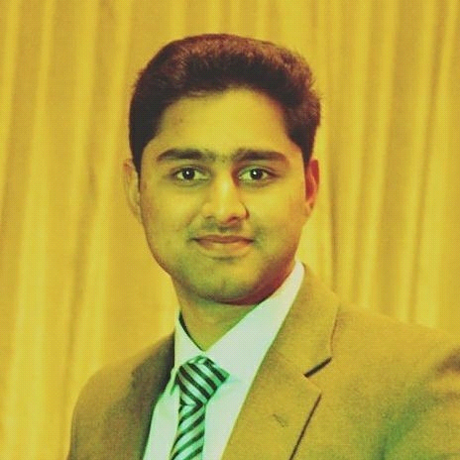
Haider Sultan
[Banda Phaughwarian, Abbottabad]
[03123559671]
[haidersultan534@gmail.com]
Personal Profile
Father Name: Sultan Muhammad
Date of Birth: 27th July,1999.
Religion: Islam
Nationality: Pakistani
CNIC Number: 13101-9825792-5
Career Objective

I am looking forward to work with a company that provides a good job environment that will not only help me to polish my skills but also will be able to give my 100% in order to help the company meet and surplus its goals.
Education
[2014-2016] [Matric] [Modernage Public School and College]

[2016-2018] [Fsc] [Modernage Public School and College]

Achievements & Participation

Awards;
- Won District level Urdu Speech Competition held at Jalal Baba Auditorium.
- Awarded by Comsats Institute of Information & Technology Abbottabad for getting 2nd position in English Speech Competition on Earth Day.
- Participated in 8th National Convention on Student Quality Circle at Modernage Public School & College , Abbottabad and got 2nd Position in debate competition.

Participation;
- Participated as a delegate at the Srilanka - Pakistan Youth exchange programme.
- Attended NATURE - QUDRAT debate competition among students from various schools of district Abbottabad at Jalal Baba Auditorium Abbottabad.
- Participated in SHAHZADA KHAN MEMORIAL TREE PLANTATION CAMPAIGN.
- Participated in many other co-curricular activities including debate competitions, Quiz , Dialouge writing , Dramatic society , Poetry Competitions and sports.

Posts and responsibilities:
- Founder of Rise up ( Student Welfare Organization) Abbottabad
- President of Youth Empowerment Expo
- Former Co-ordinator Orphan Alkhidmat Foundation
- Ambassador Codematics Blood Community
Employment:
- Worked as Telemarketing agent at Centaurus Bpo (Abbottabad) from July 2018 till March 2019.
- Worked as Telemarketing agent at WORK (Rawalpindi) from April 2019 till July 2019.
- Worked as Manager at Leads Bpo from August 2019 to April 2020.
Campaigns worked on:
- O2-mobile network (UK)
- 3-mobile network (UK)
- Survey (UK)
- Solar (US)
- Diabetic (US)
- Auto Insurance (US)
CORE COMPETENCIES:

- Innovative and have problem solving skills
- Good interpersonal skills.
- Good at coordination and taking initiatives

Hobbies and interests:
- Love to organize educational and fun filled events.
- Feel pleasure in doing welfare tasks.
- Always ready to participate in dramatics.

References:
Will be provided if needed.

