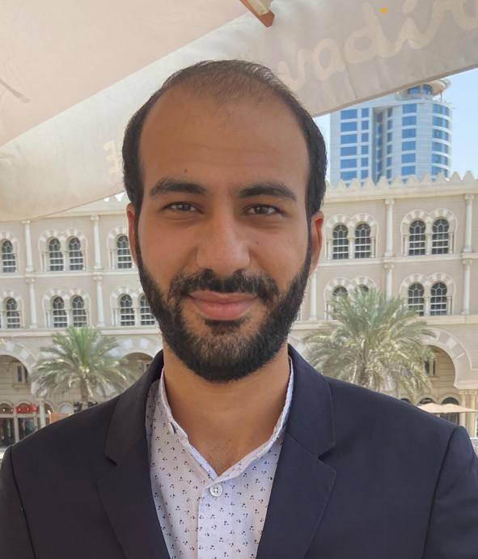

Rimoun Mamdouh Mahrous
Salesman - Administrative officer - Customer Serivce

Personal Information:

Date of Birth: 9/3/1994
Mobile Phone: +971547458809
E-mail: remonmmdoh@gmail.com
Marital status: Single
Nationality: Egyptian
Address: Sharjah , United Arab Emirates
Career Objectives:
A challenging career at a reputable organization where I can add value to the organization and myself through sharpening the skills and knowledge I have gained throughout my Education,Working Experience and Extracurricular activities.

Educational Background:
- Bachelor of commerce (Business administration) Giza Higher institute for managerial Sciences.
Skills and competencies:
- Good at negotiation and agreements .
- Having excellent persuasive skills.
- Handling issues wisely with a fast response .
- Collaborated and working with a team .
- Having an eyes on details.
- Time management and deadline-oriented .
- Confidentiality and professionalism .
- Controlling,budegting and decision-making .
- Good at critical thinking skills.
- Having General business knowledge especially in sales and marketing .
- Self learner and easily adapted to all circumstances and situations .
- Reporting research results and data entry .
- Creativity in solving problems and suggestions.
- Building strong connections through well-communication skills .
- Excellent listening skills and paraphrasing.
- Microsofr Office

Work Experience:
- Past 2017-2018: Accountant for most popular Antiques Auction in Egypt Called Osiris .
- Past 2018-2019: Front Desk for Queen Exchange in Egypt.
- Past 2019-2020: Call Center & Customer Service in for well-renowned company called Alraya contact center.
- Past 2020-2022: salesman & administrative officer performing all the various administrative tasks in the office El-Dar company for steel and Aluminum works (Marketing & Sales-Negotiate for best deals and make contracts agreements for long terms ).

Certificates:
- Bachelor of commerce certificate.
- Two year experience in sales & Admin & Customer Service certificate.

Languages:
- English
- Arabic (Native)

