Mr. Shashikant Mehra  Silicon Oasis, Dubai, UAE.  Mehrashashikant21@gmail.com  +971 0528072721  Visa Status: Resident Visa. | 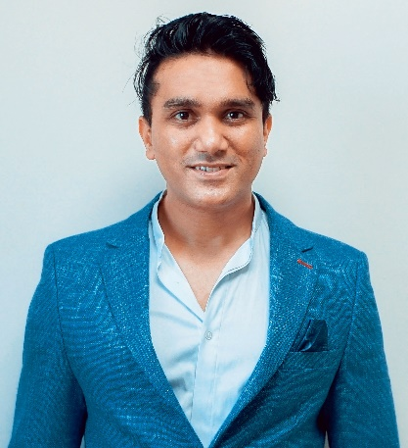
Profile Summary:

I carry 11 years customer service Experience & Graphic Designing in a fast-paced environment seeking an opportunity in a team-orientated company. Adept at handling a wide range of contact methods while accurately documenting customer issues and providing best service with every interaction.
Work Experience:

WordPress website management

SOFTWARE KNOWN:
Adobe Photoshop
Adobe Illustrator
Sony Vegas
Filmora

PHOTOGRAPHY & VIDEOGRAPHY AT STAYZILLA: (JAN 2019 - June 2022)

- Did 100+ real estate Property and hotel room photo shoot, Food Photography.
- I am a well versed with Photoshop editing.
- Did Product shoot for e-commerce website like eBay.
- Worked as a seller on eBay.
- Videography, Color correcting video, splitting scenes.
- Dialogues editing with the scenes, De noising Vocal, removing background with green
- Screen. Effect, adding transition effect, Adding letter box to the scene for Cinematic look
- Rendering as desired format.
- Product photoshoot with white background for Ecommerce website

Tele performance BPO - Customer Care Executive - (August 2014 – September 2019) Mumbai.
Job Responsibilities:
- Handling incoming Barclays banking process for UK customer.
- Resolving the customers queries regarding Barclays debit card.
- Booking Appointment for the customer to visit Barclays branch.
- Taking complaint calls directing them to right department.

Tech Mahindra International BPO - Customer Care Executive –( March 2011 –August 2014),Mumbai
Job Responsibilities:
- Worked as technical support executive for Vodafone process.
- Helped the customer with troubleshooting step.
- Replaced the phone if there was a fault with the device.
- Raised the service request (SR) if there was no coverage bar.

Tata Consultancy Services (TCS) – International BPO –Customer Care Services-(Nov 2007-Jan 2011).
Job Responsibilities:
- Handling incoming calls for Credit Card customer care (Business card US process).
- Resolving the customers queries regarding Credit card, bank charges, interest rate change, late fee, annual fees.
- All banking related queries.

First Source International BPO – International BPO- Customer Care Service-(Jan 2007 – Nov 2007).
Job Responsibilities:

- It was a contractual job for Credit Card customer care.
- All banking related queries.

Educational Qualification:

Education University Year
BSC (Graduate- Math’s) Mumbai University 2005
HSC Mumbai University 2001
SSC Mumbai University 1999
Personal Information:

Nationality : Indian
Language : English, Hindi, Punjabi.
Marital Status : Married

I hereby declare all the above-mentioned information is true to my knowledge.
( MR.SHASHIKANT MEHRA).

