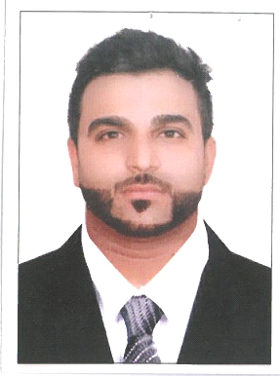
KIRBY FERNANDES
✉: kirbyfernandes@hotmail.com
☎: +971508406211

QUALIFICATION SUMMARY

A resourceful Customer-Care Specialist who consistently meets and exceeds productivity goals, whilst providing value-added solutions to the customer. A proven track-record of troubleshooting issues and resolving customer queries with efficiency and diligence. I possess a strong ability to build and maintain business relationships and thrive on converting customer dissatisfaction to loyalty.

SKILLS & KNOWLEDGE

- Phone Skills | - Listening | - Meet Deadlines
- Customer Focus | - Speak Articulately | - Customer-Oriented
- Fast and Efficient | - Calm under pressure | - Feedback
- Conflict Resolution | - Problem Solver | - Attention to detail

EXPERIENCE & ACCOMPLISHMENTS

The National Bank of Ras Al Khaimah (RAKBANK), Dubai UAE Feb 2008 – July 2019
Customer Service Specialist
- Addressing customer service inquiries in a professional, positively and timely manner;
- Assist customers with difficulties gaining access to account information online.
- Handle high call volume while delivering a high service quality
- Answer general questions regarding navigation of the website as well as account information.
- Anticipate customers’ service needs, including asking appropriate questions to better understand their requirements;
- Resolve customer complaints over the telephone, and escalating their queries and complaints to the right channels, when necessary;
- Follow-up on all bank procedures and processes, whilst fully adhering to BCP rules and regulations;
- Cross-selling credit cards as well as other bank product and service offerings;
- Provide Internet chat agent services as and when required;
- Comply with quality assurance expectations and standards;
- Document each customer's account accessed with information provided including results of the call
- Customer focus and adaptability to different personality types

CELLUCOM, Dubai, UAE 2005 – 2007
Senior Sales Merchandiser
- Supervised and trained junior staff on sales techniques, to achieve monthly and annual revenue targets;
- Offered customers seasonal deals and promotions as well as assisted the in choosing products that met their requirements and budget;
- Assisted with promotions and advertising campaigns;
- Predicted sales and profits, and promoted bestselling items to maximize profits;
- Managed levels and distribution of stock, product display setups, stock deliveries and performing stock checks;
- Handled supply/production problems as they arose;
- Liaised and advised Management on setting stock promotions/price reductions as appropriate based on customer demand;

Sure International, Dubai, UAE 2004 – 2005
Sales Merchandiser
- Based at Carrefour, Deira City Centre and directly involved in sales and promotions of white goods manufactured by Sure International;
- Assisted customers in their purchase decisions by helping them select relevant and appropriate products by offering advice and suggestions based on their requirements;
- Continuously arranged and replenished shop shelves and ensured that the shop floor and shelves were kept clean and tidy at all times;
- Watched for and prevented security risks and thefts, and escalated occurring incidents to the hierarchy in a timely manner in order to avert property loss;
- Performed physical and electronic inventory of shop products on a regular basis as per the company guidelines to ensure accurate stock keeping;

Educational qualifications

Bachelors in International Business (B.A) (Hons.) 2006- 2009
American Heritage University, Dubai, UAE

Diploma in Business Administration 2006- 2008
London City College, Dubai, UAE

LANGUAGES

English – Fluent Hindi - Fluent

