
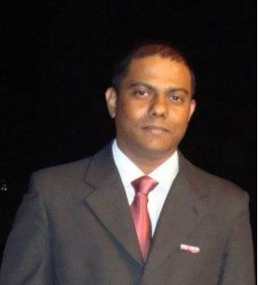
Kamal Bernard De Jacolyn

kamal.bernard@outlook.com
+94711858007/ +971553605726
 https://ae.linkedin.com/in/kamalbernard
Key Skills  Cloud Engineering / Security (Azure) | A diligent, result-oriented & accomplished Microsoft Azure Certified professional, offering 17 years of experience; targeting assignments in Cloud Engineering | Cloud Security | Robotic Process Automation role, preferably in Dubai, United Arab Emirates.
  UiPath Robotic Process Automation
  System Back-Up & Recovery
  System Administration
  Application Support L1/ L2
  Hardware /Software Troubleshooting
  Server Preventative Measures
  Incident Management
  Team Leadership & Development
 | Profile Summary
- Currently working with Landmark Group (Funcity LLC a part of Landmark Hospitality), UAE as IT Systems Executive (EMBED Gaming/ Redemption Ticketing System)/
- Proficiency in application support, IT infrastructure, L 1/2 support establishing SOPs; managing Azure Subscriptions; using Azure portal; troubleshooting cloud-based ERP application; working with Azure Active directory users; Automation Process workflows, creating software BOT’s using Ui Path and RPA Engineering. Develop in UAT machine
- Successfully managed technical fault analysis; provided infrastructure support; technical support; led system back-up on premises as well as cloud based.; L2 Support, Implemented BOT’s and RPA for inventory System. supervised delivery & installations for IT Projects across GCC countries.
- Credibility in conducting technical architecture analysis, planning, designing,
- Excellence in setting up Cloud Infrastructure right from scratch, leading entire application migration to cloud, providing end-to-end cloud solutions & interacting with CXO Level Executives at client-end (technical aspects)
- Key role in Development & Execution Architecture (Sizing, Output Management & Security Design, Technical Integration), Operations Architecture (Back-up, Recovery, HADR & Monitoring), Infrastructure Architecture (Sizing, Network & Virtualization)
- Proficient in motivating, mentoring & leading talented professionals; directed cross-functional teams using interactive & motivational leadership

Certifications

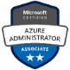
- Microsoft Certified Azure Artificial Intelligence - Ai 900 Exam
https://www.youracclaim.com/badges/21e4fa52-8568-49df-b3f6-2101e55e61e8/public_url
- Microsoft Certified Azure Administrator AZ 104 exam
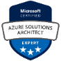
https://www.youracclaim.com/badges/d713fef2-d661-4611-836d-47196937f50e/public_url
- Microsoft Certified Azure Solution Architect Expert
https://www.youracclaim.com/badges/6bb7f785-35d8-4d73-9f56-2467e7cdc1fd/public_url
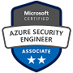
- Microsoft Certified Azure Security Engineer Az500 Exam
https://www.youracclaim.com/badges/a3e6ae44-5327-4b39-943a-a13f3a2dca68/emai
- Fortinet Network Security Associate (NSE2)


Education

- Bachelors Science Degree (IT) from Sri Lanka Institute of information Technology (3 years) in 2008

- BTEC -i level 6 Higher National Diploma (IT) from Ed-Excel UK (2 years) in 2008

- National Diploma (IT) from Sri Lanka institute of Information Technology (2 years) in 2008
Soft Skills

Analytical
Leader
Creative Thinker

Collaborator
Communicator
Planner

Personal Details

Date of Birth: 02nd June 1982
Languages Known: English, Hindi & Sinhala
Address: Al-Barsha 1, Dubai, UAE
Contact Number: +971 - 553605726

 Career Timeline

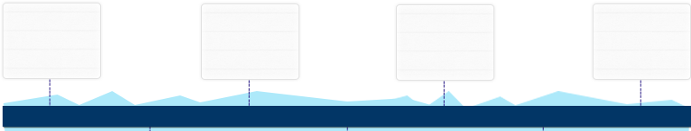
Jan’03 to Jan’04

Sri Lanka Telcom, Sri Lanka as Computer Systems Operator
Jan’08 to Dec’16
Danube Home/Danube,
Al-Danube U.A.E as Sr.IT Systems Administrator
Sep’04 to Nov’07

Softlogic Computers, Sri Lanka as Customer Support Executive
Since Feb’17

Landmark Group, UAE as Sr. IT Systems Executive
/ Systems Analyst

Work Experience

Since Feb’2017 till date Landmark Group (Funcity LLC a part of Landmark Hospitality), UAE
as IT Systems Executive (EMBED Gaming/ Redemption Ticketing System)/ Systems Executive

Tools used: Cloud-based Gaming Card System, EMBED Card, SQL Server

 Key Result Areas:

- Steering:
- Application support for computer gaming; providing L2 support; maintaining uptime in all Family Entertainment Centers across GCC
- IT infrastructure support; providing Level 1 & Level 2 support both on site & remote for FEC center across GCC regions
- Deploying and configuring virtual machine based on organizational policies & compliance
- Establishing Standards Operating Procedures (SOPs) for IT team; performing system & business analysis; ensuring that existing technologies used by company are providing optimum service to internal & external customers
- Directing application testing; setting up & maintaining content delivery systems; managing Azure Subscriptions; making cost analysis; organizing cost analysis on resources & server using Azure portal; creating reports & integration
- Develop Robotic Process Automation workflows using UiPath Studio for deferent departments that will eliminate manual work.
- Administering incidents hardware & software issue; resolving them based on agreed SLA timings
- Spearheading endpoint security systems & servers; working with Azure Active directory users; creating Azure policies for teams; conducting routine preventative measures on servers and client systems, patch management

Jan’08 to Dec’16 Danube Home/Danube, Jabel Ali Free Zone, Al-Danube UAE as Sr. IT Systems Administrator

Tools used: UiPath, SolarWinds, IMSS, Exchange Server, AVATI & SCCM along with other 3rd party applications
X
Knowledge Purview

Windows servers systems, End Point Security, Group policy management, Patch management software’s, RAID configurations, Open source applications & so on

 Key Result Areas:

- Managed technical fault analysis; provided Tire-II IT Support for all Retail stores in GCC & overseas
- Facilitated:
  - Infrastructure support on agreed SLA timing & diagnosing; tools used: Net Helpdesk & ManageEngine
  - Assistance to IT coordinators to troubleshoot hardware software issues; provided training to the team
  - Technical support for in-house & outsourced applications & testing
- Spearheaded system back-up; created backup policies & scripts for critical applications
- Formulated reports & mentioned solutions; publish it in help desk knowledge base for future reference to IT Team
- Supervised & configured site-to-site VPN and point-to-site VPN networks & installed security patches on windows systems
- Liaised with vendors; invited them for POCs; provided recommendation for delivery & installations for IT Projects

Previous Work Experience

Sep’04 to Nov’07 Softlogic Computers, Sri Lanka as Customer Support Executive (4 Years)

Jan’03 to Jan’04 Sri Lanka Telcom, Sri Lanka as Computer Systems Operator (1 Year Contractual)

 Internship

Organisation: Access International
Duration: 1 Year
Highlight: OTIS /LG Elevator Technician

Future Studies: Currently I am Studying on Artificial Intelligence Technologies & Robotic Process Automation Certifications as well as Data Science modules.

