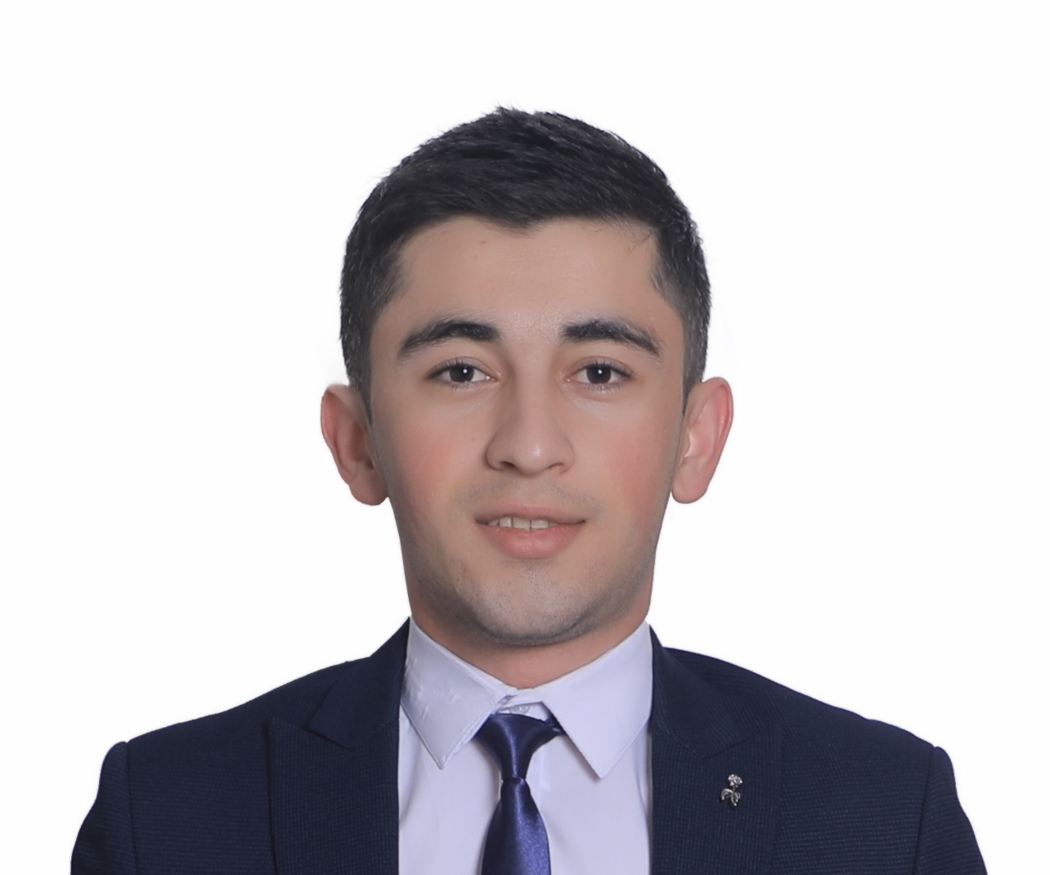
Shakhzod

Fayzulloev

Date of birth: 06/09/1998
Permanent address: Al Rigga, Dubai, UAE
Mobile: +971543465152
E-mail: shakhzod117799@gmail.com
Nationality: Uzbekistan

JOB OBJECTIVE

With a high school degree in English Language and Philology at local University and several years of hospitality work experience and in educational management organizations. I am looking for other challenges great training and long term career development opportunities. I am flexible to travel anywhere internationally. My key strength includes strong analytical and numerical skills, a keen eye for detail and quality, and positive communication and interpersonal skills. I enjoy working in a team and helping others to progress. At the same time I work well independently.

QUALIFICATION

2017 June Lyceum Graduation Certificate with Excellent Grades
2017 August IELTS Certificate with 7.0 Band Score
2018 June Certificate of “Perspective” Language centre in Bukhara branch
PROFFESIONAL CAREER

. 2018 Jan-2019 August:
Manager of “Perspective” Language center in Uzbekistan

-Ensuring that all daily routines are adhered to.
-Coordination and planning activities.
-Meeting with parents and encouraging their involvement in the aims
-Providing excellent standards of education for students.
-Keeping accurate administrative records of students’ development

2019 Sep- 2021 Jan: Opening Bartender at “Play Restaurant and Lounge”, Dubai, UAE

-opening team member
- focus on bar staff training
- supervising new members of bar staff
- cocktail list development
- maintaining appropriate stock levels for the bar
- order required spirits, liqueurs, soft drinks and supplies
- dealing with guests in line with the high standard of service
- ensuring that customers receive an efficient and prompt service

2021 Jan- Present: Patient Engagement Officer at “Canadian Specialist Hospital”, Dubai, UAE

-working with and developing the groups and the engaging with GP practice
-answer inbound calls in a timely and friendly manner
-evaluate problems and complaints of the callers and provide proper solutions to them
-respond to the needs of Patients and provide personalized service
-provide information on the company’s services and generate interest in the offer

SKILLS & INTERESTS

Computer skills: Computer Programming and Design, MS Office, Power Point, Excel, Opera, Internet research
Language: English-Advanced Russian-Advanced
Uzbek (Native) German-Basic
Interests:
Interested in travelling, reading and learning new languages.
Collecting Foreign Currency, Photography, Swimming, Football, Ping-pong, Basketball

All references are available upon request

