Ajitha.S  E MAIL: - Ajithajackulin8@gmail.com  Mobile No: 0505427347  43, Farm house,  AL Hudaibha Street,  Near Ibrahim Bin Hamad Obadiahulla Hospital, Al Seer, Ras Al Khaima. | 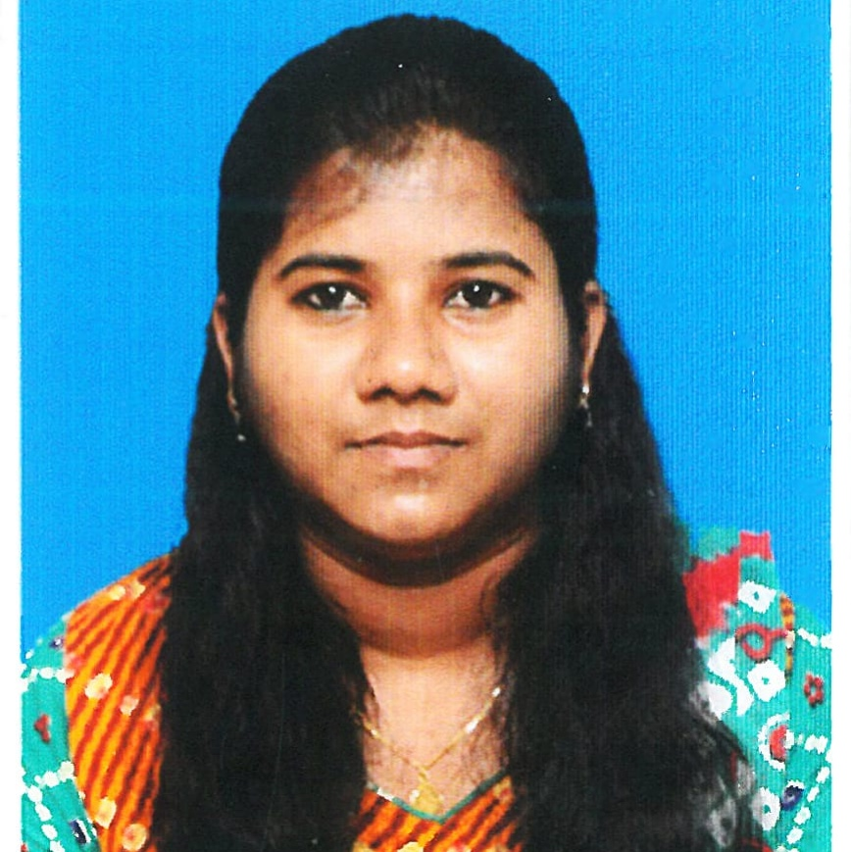

Career Objective:
To Work for a reputed concern and progressive firm so as to pursue a provoked and challenging career by utilizing best of my skills, professionalism and responsibilities in the field of financial institutions. I like to be a part of team and to make my contributions that help to achieve the companys Objective.

Professional Experience:
Overall Experience: 7.3 Years
Current Experience:
Organization : State Street HCL Services Ltd (From April 2018 Till Now)
Job Title : Team Leader Global Dividends
Achievements : Best Performer and Extra Miler

Global Dividends:
- Dividends that are declared in markets will be feeded into system through primary and secondary sources. This further will be pulled into reports and events that are not auto confirmed needs to be confirmed manually by validating other sources.
- Based on Market guidelines, the dividends are confirmed in the system and Confirmed Dividends will further be processed by accounting team and dividends will be paid to the holders.
- Payments that are pending from Lending agents are reported to them along with their current holdings and expected payments.
- Updating details of Dividends that are confirmed in systems into middle office application.
- Notifying downstream teams regarding the securities that are going to be defaulted in markets by reviewing MT564 swift messages and verifying sources.

Work Experience:

Organization : Fidelity Investments Pvt Ltd (From Oct 2016 -To April 2018)
Job Title : Senior Associate Asset Management
Achievements : Two Zero Defect Award and Raise and Toast

- Efficiently managed every accounting task handled over by team supervisors and completed task to satisfaction
- Undertaken responsibilities in preparation of monthly Reports.
- Assist in the audit of data with source documents
- Handled onshore calls for verification of Investment advisors demographic details.
- Assisted in preparation of supporting schedules for auditor
- Performed general office duties and administrative task.
- Scheduled client appointments and maintained up to date confidential client files.

Organization : Maersk Global service Centres India Pvt Ltd (From Sep 2014 – To Sep 2016)
Job Title : Associate Accounts Payable.
Achievements : Extra mile award (2016)

Invoice processing (Request to Pay)

- Processing of Vendor invoices (Purchase Order-Goods Receipt-Invoice matching).
- Ensuring the three way match is standardized for all countries to have the FTHR increasing Responsible for all Accounts Payable processes.
- Verify the correctness of vendor bank details against SAP vendor Master data.
- Duplicate invoice check controls.
- Resolving country queries.
- Take FTHR report for Europe region to increases the percentage.
- Take open PO reports to match the carrier statement invoices for process.
- Follow the standard procedure in posting/forwarding for different regions in Europe.
- Handle urgent payment and advance payment and also clear the vendor invoices on stop.
- Verify posted invoices on vendor wise and send to the payment team.

Academic Profile:

Name of the Institution | Degree | Percentage of Marks | Year of Completion
Madras Christian College | BBA | 72% | 2014
Kendriya Vidyalaya Meenambakkam | H.S.C(+2) | 78% | 2011
Kendriya Vidyalaya No:2,Tambaram | S.S.L.C | 50% | 2009

STRENGTHS:

  - Self-motivating and a passion to succeed.
  - Flexible to work.
  - Quick learner.
  - Good team builder and hard worker.

TECHNICAL QUALIFICATION:
  - MS Office (Excel, word & PowerPoint).
- SAP
- KEWILL
- DCA in computer Application
- MCH

INTERESTS:
- Sports
- Driving

PERSONAL INFORMATION:

Date of Birth : 05.10.1992

Fathers name : C.Sugumaran

Gender : Female

Nationality : Indian

Language : Tamil (Read & write), English (Read & write) & Hindi (Read & write)

Marital Status : Single

Place : CHENNAI

Date : (Ajitha S)

