Curriculum Vitae

KIRAN RENNY
85A Mackworth Street, Christchurch-8062
Contact number: +918281643397
kiran.renny2015@gmail.com

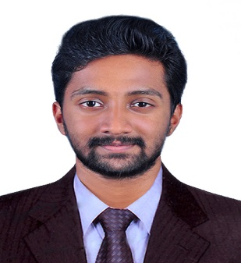
CAREER OBJECTIVE:
To gain experience in the field of logistics and to develop all necessary skill set required that would help me pave my career path in logistics.

ACADEMIC QUALIFICATIONS:
- Graduate Diploma in Logistics & Supply Chain Management
ARA institute of Canterbury. New Zealand
- SAP (Material Management and Inventory Management)
- Bachelor of Business Administration (BBA)
MG University Kerala India. (2015-2018)
- CBSE Grade 12, Carmel Public School, Kerala India.
- CBSE Grade 10, Al Wurood INTL School, Jeddah, Saudi Arabia

WORK EXPERIENCE
- Warehouse Supervisor: Bidfood Logistics, Christchurch. NZ (Sept 2019 – Nov 2020)
- Travel Agent: Brook and Dale Holidays Pvt.ltd. (Family business 2017-18)
- Surveyor: Axon Market Research.(Government of Kerala KSTP Project/2018)
- Operations Trainee: Rajagiri Multi Specialty Hospital Kochi Kerala (Internship 2018)

SKILLS:
- Freight Forwarding  - Strong Numerical and Analytical Skills  - RF Scanning  - Good Communication Skill  - Product Dispatching  - Import and Export Management  - Adaptability and Accountability  - Forward Thinking  - Sound Decision Making  - Team Player  - Keen attention to detail  PERSONAL DETAILS:  Date of Birth : 22nd June 1996  Languages : English, Hindi & Arabic  Permanent Ad : RiverGate Villas & Apartments  Manakadu, Thodupuzha, Kerala,  India 685608  Tel. 00919995553615  Passport Number : S8714710  Nationality : Indian  Marital Status : Single  Driving License : Holder of Indian International /  New Zealand Driving License | - Microsoft Word  - Microsoft Power Point  - Microsoft Excel  - Tally  - C+  - Microsoft Project

DECLARATION OF AUTHENTICITY:
I hereby declare that the information furnished above is true to the best of my knowledge and belief.
Kiran Renny
Christchurch, New Zealand

