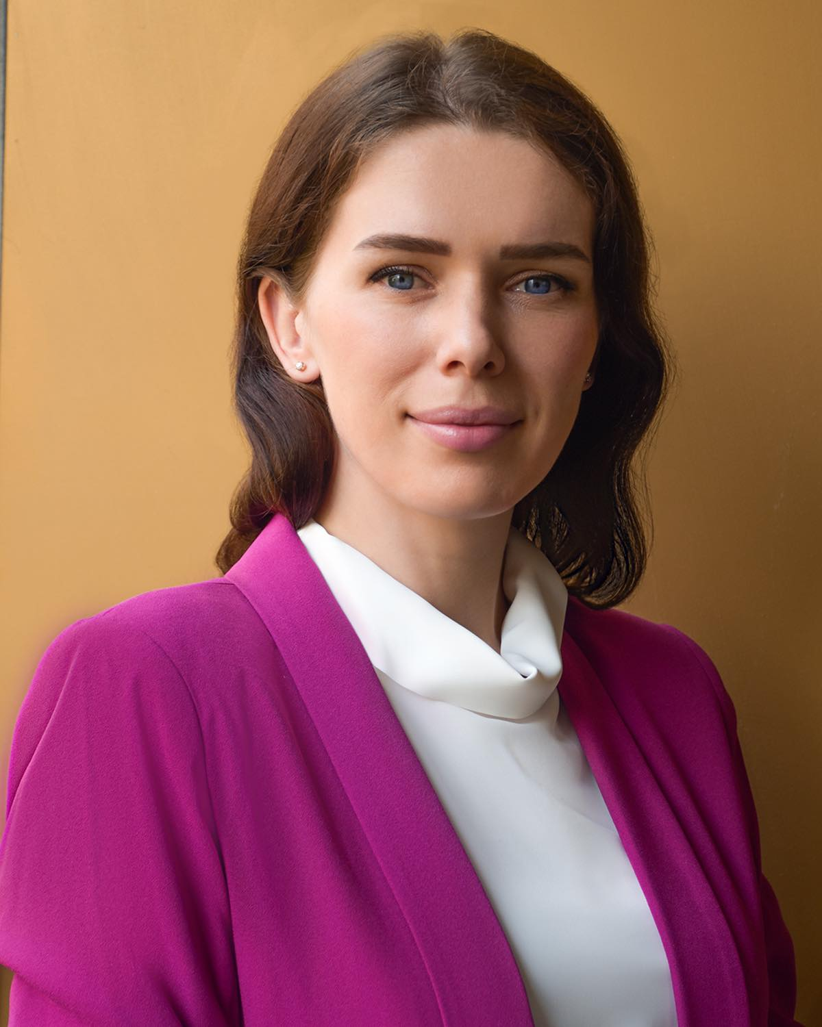 |  | kseniia Sytnyk  PROFESSIONAL SUMMARY  Highly motivated young professional.  Discipline, multitasking, excellent communication abilities are some of my professional and personal skills.
PROFILE  Nationality: Ukrainian  Date of birth: 10/07/1992  Driver license class B  USA visa (2017-2027)  Contact  PHONE:  380964891306  EMAIL:  ksenia.sytnyk@hotmail.com  Skills  -Computer and mobile literacy  -Time management  -Strong ability in teamwork  -Problem resolution  - Team Leadership  - Excellent communication abilities.  Hobbies  -Travel  -Volleyball  -Snowboarding  -Photography |  | WORK EXPERIENCE  Etihad Airways - Cabin Crew – Abu Dhabi  02/2016– current  - Delivering safety and customer services efficiently and with highest level of accuracy.  - Consistently receiving high marks on customer satisfaction and recognitions from colleagues.  - Due to outstanding level of customer and communication skills was chosen for Presidential Flight interview.  - Alongside passenger flights, operating more than 10 freight flights since 2021, fully accountable for documentation and cargo on board.  - Volunteering and taking part in Etihad Airways’ promotions.  - Being recognized for achieving 100% attendance records and for highest scores on emergency and first aid exams every 6 months.  Work and Travel – Coordinator - Kiev  07/2014– 01/2016  - Recruiting more than 150 students for Work and Travel program.  - Primary contact with potential employees, addressing all travel community concerns and providing daily practical solutions.  - Verifying and finalizing arrangements to ensure smooth and efficient travel for all employees.  - Negotiating with USA employers.  Englex - English Teacher - Kiev  01/2012 to 07/2014  - Preparing and implementing lesson plans covering required course topics.  - Boosting achievements to exceed targets and forecasts for more than 90% of students.  - Initiated new working methodologies, including small-group work and problem-solving assignments.  - Improved standardized test scores by an average of 12.5% amongst students in my classes.  Sales Manager Elite Sport - Kiev  08/2010 to 08/2011  - Coaching employees in successful selling methods and encouraging cross-selling to drive revenue.  - Organizing promotional events of sports goods and increasing sales volume by 17% annually.  - Redesigned critical components of sales operations to retain customers.  - Promoted to a supervisor position, where I lead and motivated 3 stuff members.  EDUCATION  Bachelor’s degree:  National University of Aviation - Kiev, Ukraine  Transport Technologies (in Air Transport) 2009-2014  Faculty: Air transport technologies  Master of Business Administration (2020-2021)  IUBH University of Applied Sciences – Berlin  Certifications  IELTS certificate (score 7,5)  Leadership and Team Development certificate (International Business Management Institute)  Certificate in Business Administration Level 2 (Oxford HSC)

