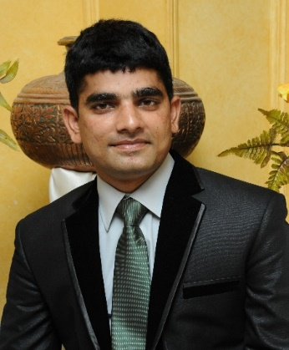
󠆽
- Management & Administration
- Executive Secretary
- Event Organization
- Problem Solving
- Computer Proficient
- Law Qualified
- Security & Safety

- Executive Secretary
Four Brothers Group of Companies, Lahore
One Year - 2020 -2021
- Safety & Security Coordinator/ Management Officer
Agha Khan University Hospital, Karachi
Joined on - 13 July 2021

CIVIL EXPERIENCE
- 13 years of experience in Administration, Management, Security and Protocol Duties in Pak Army (2008-2020)
- Rescued own troops from Taliban attack in Waziristan by managing Artillery Fire and awarded “Golden Stripe”
- Admin Officer (Quarter Master) in Construction & Establishment of Unit Headquarter - Neelum Valley
- Grade-III Staff Officer in a Brigade Headquarter, managing all official correspondence of Brigade Commander
- Remained lynchpin of Corps Headquarters team (GSO-2) for managing all official functions & ceremonies in Lahore
- Managed administration & Security of Jinnah House (Lahore Corps Comd House) for three years with diligence

MILITARY EXPERIENCE
- Junior Staff Course (JSC) & (MCC), Nowshera
- Officers Gunnery Staff course (OGS), Nowshera
- ICRC (Red Cross) conflict course, LUMS Lahore
- Forward Air Controller (FAC), PAF Base, Karachi
- Quick Reaction Force Security Course (QRF), Bahawalpur
- Intermediate - 2004
Forman Christian College, Lahore
- Graduation - 2008
Pakistan Military Academy, Abbottabad
- MSc - 2015
Military Studies from Peshawar University
- LLB - 2021
Punjab University

MILITARY COURSES/ CADRES
󠄄
EDUCATION
00923317495785
CONTACT
󠄄
󠄄
formanite117@hotmail.com
Lahore, Pakistan
HOBBIES
Writing

Book Reading
󠄄
Music
󠄄♫
STRENGTHS
Highly energetic, motivated, well-traveled and creative with practiced experience in a large organization. Recognized for the ability to create trust and complete work for superior quality with minimum supervision
PROFILE
MAJ (Retd) FAYYAZ ANJUM

CURICULUM VITAE

