    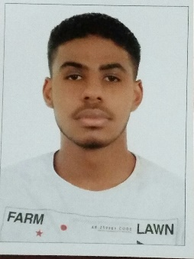  mbbalo15@gmail.com  mahjoub-99@hotmail.com  +971503661868 +971504778710  Butina, Sharjah, UAE |  |  |  | Mahgoub Omer  Experience  2 months – 2020  Undergraduate Research Assistant • University of Sharjah  1 month – 2019  Promoter at Early Learning Center • 3Doodler  1 month – 2018  Data Entry Operator • Egyptian Company  1 month – 2018  Call Center Agent • TNS  Education  Bachelor of Science in Mechanical Engineering, University of Sharjah – UAE, 2020  Sharjah International Private School, UAE, 2016  IELTS (overall of 7.0), UAE, 2016  Skills  Computer skills: MS Word, MS Excel, MS Power Point, AutoCAD, MATLAB, SolidWorks, CodeBlocks (C++), LEGO Mindstorms EV3, Naza M Lite Assistant  Strong problem solving, organizational and time management skills  Ability to work under pressure and adapt to dynamic environments  Fast typing and Multi-tasking skills  Excellent in speaking, reading, and writing in both English and Arabic  Publications  Haider Ghassan, Mahgoub Omar, Kerolos Soliman, Ibrahim Alhouti, M AlShabi, and Mamdouh EL Haj, Hybrid drone: gasoline engines and electric motors, SPIE Defense + Commercial Sensing (SI20), 11425-40, Unmanned Systems Technology XXII, 2020, USA  References  [Available upon request.]

Personal Information
DOB: 10/02/1999
Nationality: Sudanese
Driver’s license (UAE)
Residence Visa (UAE)

