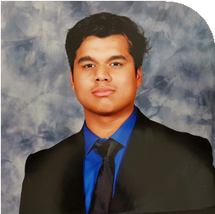 +971 56 207 3148
ALLEN DSOUZA
F I N A N C E S T U D E N T

dsouzaallen1@gmail.com Abu Dhabi/Dubai
linkedin.com/in/allen-dsouza-718444a7

I N T E R E S T S
Volunteering Programming Gaming

P R O F I L E

I am an undergraduate student in Murdoch University Dubai, majoring in Finance. I am actively looking for career opportunities and I aspire to be a good Financial Analyst in the future.

E X P E R I E N C E

CLUB PRESIDENT OF CYBER CLUB
Abu Dhabi Indian School
2020- 2021

President of Cybernauts club for the year 2021-2022
helped the club members to develop proficiency in Web and Bot development.

E D U C A T I O N

SECONDARY SCHOOL
Abu Dhabi Indian School- Commerce
2007-2021

BACHELOR OF BUSINESS
Murdoch University Dubai
2021- Present
ONLINE NSE ACADEMY CERTIFIED CAPITAL MARKET PROFESSIONAL ( E- NCCMP)
NSE Academy
2021- 2022
OPTIONS TRADING MASTERCLASS: OPTIONS WITH TECHNICAL ANALYSIS
Udemy Academy
2021

DISCORD BOT DEVELOPER
2020- 2022

Developed a discord python bot, which included many economy functions and automation.

S K I L L S
Financial Literacy
Programming (Python and SQL) Financial Analysis Collaboration
Problem-Solving Computer Literacy Time Management Data analysis
Bot development

