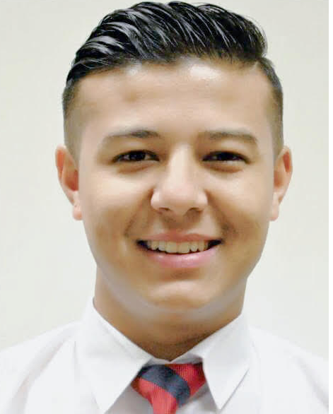
Karan Jung Dotel
PERSONAL Date of birth:02 july 1995.
INFORMATION Marital status: Single.
Nationality: Nepali.
Location: currently in Sharjah

CONTACT Al Warqa Mobile Number: +9710556987253
MAF Apartment E-mail: karanjungdotel10@gmail.com
Dubai U.A.E Skype: karanjungdotel10

OBJECTIVE I am looking for a permanent and challenging work with friendly staff at FO position. I would like to work in an environment where I can have space to develop myself in an international career further. My aim to hold a position that would enable me to exercise my communicative power, implement my knowledge and skills, work on the image and prosperity of the company, where my 6 years of retail experience can be fully utilized to improve bottom line and the company revenues. Together bring joy to every client, give a smile and a desire to be sure to come back.

WORK Carrefour Hyper U.A.E 2017 — Present
EXPERIENCE (Retail Supermarket in dubai)

As a Cashier Supervisor
- Assisting and training cashiers in sales techniques, providing excellent customer service, problem solving and daily cash balancing operations.
- Calculate total payments received during a time period, and reconcile this with total sales.
- Responsible for maintaining cashier weekly schedule and filling in any unscheduled time off.
- Completing all daily responsibilities and effectively responding to customer inquiries and complaints.

Carrefour hyper market 2016 — 2017

Sales clerk
- Collect, count, and disburse money, do basic bookkeeping and complete banking transactions.
- Compute, record, and proofread data and other information, such as records or reports.
- Maintain and update filing, inventory, mailing, and database systems, either manually or using a computer.
- Open, sort and route incoming mail, answer correspondence, and prepare outgoing mail.

Carrefour hyper market | 2015 — 2016

Cash room officer
- Cash Flow: preparing money for all departments, monitoring cash level, and handling money order and petty cash supply.
- Paper Works: completing a variety of paperwork by hand, or via accounting, word processing, or spreadsheet software on a daily and weekly basics.
- Collection: collect money and sales papers from cashiers and managers. Preparing the money for bank deposit after comparing totals against receipt.

Carrefour hyper market | 2014 — 2015
Cashier
- Receiving payments from customers using various mode as cash, debit cards, CREDIT CARDS, and demand draft etc.
- Make the records of cash and all other payment together as well as separately.
- Maintaining the soft copy and hard copy of all the daily transaction for future references

EDUCATION Xth standard (Aakash Deep English Secondary school) 2002 TO 2011
XIth and XIIth (Premier International College) 2011 to 2013

LANGUAGES Nepali – Native
SKILLS Hindi ــ Native
English ــ Fluent

COMPUTER Microsoft Ofﬁce (Word, Excel, Access, PowerPoint,Outlook Express),
SKILLS internet (MS Explorer, Opera) and others.

PERSONAL -Well-developed communication soft skills.
QUALITIES - Have a clientele knowledge able to build relationships easily
-Enthusiastic, proactive and committed to excellence in the work.
-Good understanding of cultural awareness.
-Well-developed organizational skills.
-Flexibility.

REFERENCES References available upon request.

