
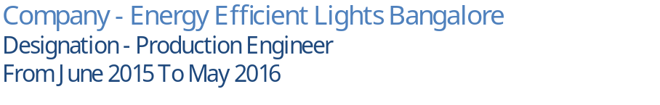
Bangalore International Airport
Company - Air India SATS
Designation - Security Officer
From March 2017 to May 2018
Currently working in Abu Dhabi International Airport as security officer since June 2019
Company - Securiguard Middle East LLC
Designation - Security Officer

Embedded System and Robotics Eikon Technologies
Bangalore | 2016
- Cargo clearance & Management.
- Managing CCTV Surveillance & Operations.
- Evaluate current production activities and make recommendations for improvements.
- Implement cost reduction initiatives while maintaining high quality standards.
- Develop operating instructions and equipment specifications for production activities.
RESPONSIBILITIES

Mr. Mohamed Ismail
Securiguard Middle East LLC
+971558891913
- English
- Hindi
- Malayalam
LANGUAGES

- Cargo Clearance

- Embedded Systems

- Robotics by Embedded Architecture

- ARM Processor

WORK EXPERIENCE
High school
Kerala state Board
Pathanamthitta | 2007 - 2009
Higher Secondary School
Kerala State Board
Pathanamthitta | 2008 - 2011
- 0543010676, 0508714438
- agnisookthangal@gmail.com

Current location - Abu Dhabi
UAE ID NO - 784-1993-0968365-6
Passport No - R4626759

Permanent Address - Marurethu (H), Vallicode PO, Pathanamthitta, Kerala, India. PIN 689648

9
Nationality – Indian
Date of Birth – 21/09/1993
PERSONAL DETAILS
EXPERTISE

B Tech (Electronics & Communication Engineering) Anna University Chennai Salem | 2011 - 2015

BINU RAJASEKHARAN

To employ my knowledge and experience with the intention of securing a professional career with opportunity for challenges and career advancement, while gaining knowledge of new skills and expertise
EDUCATION

REFERENCES

