GET IN CONTACT
Mobile : 056-5777069
Email: danielkeziah77@gmail.com

PERSONAL PROFILE
I am flexible, reliable and possess excellent time keeping skills. I am an enthusiastic, self-motivated, reliable, responsible and hard working person. I am a mature team worker and adaptable to all challenging situations. I am able to work well both in a team and environment as well as using own initiative.

PERSONAL DETAILS
Date of birth: 13.02.2001
Gender: Female
Marital status: Single
Nationality: Indian
Religion: Christian

AREAS OF EXPERTISE
Microsoft word
Microsoft powerpoint Microsoft excel ( basics)

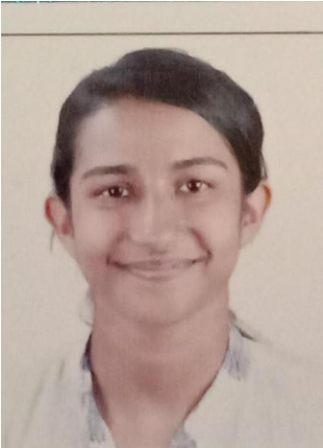
______________
KEZIAH BABU DANIEL

DECLARATION

LANGUAGES KNOWN
ENGLISH (WRITING AND SPEAKING)
HINDI (SPEAKING)
MALAYALAM (SPEAKING)
ARABIC (READING)

EDUCATION HISTORY
GRADE 12: BUDS PUBLIC SCHOOL, DUBAI GRADE 10 (CBSE): OUR OWN SCHOOL, WARQA, DUBAI

___________________________________________

WORKING EXPERIENCES
Worked in Gulf car festivals (promotions)
Worked in Du (promotions)
Worked in DFC (promotions)
_________________________________________________

OTHER SKILLS
Excels at multi-tasking in a fast-paced environment and completing projects within the time.
Punctuality and efficiency.
Solid multi-tasking and time management skills. Highly organized and friendly professional.
Skilled at interpersonal communications

I hereby declare that the above written particulars and information are true to the best of my knowledge.

KEZIAH BABU DANIEL

