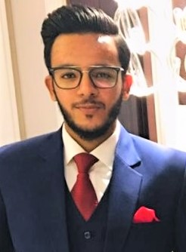
MUHAMMAD HASSAAN SIDDIQUI

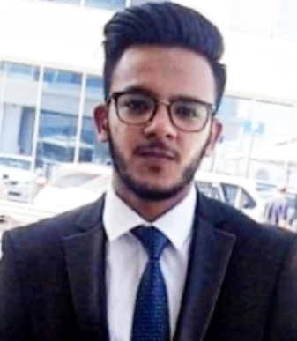
NEW AL SHAMS BUILDING, AL QUSAIS, DUBAI.
 P.O.BOX NO: 6413  +971 55 – 124 22 77
 04 – 339 1829
 hassan_sid90@hotmail.com
Linkedin: www.linkedin.com/in/hassansid90
Objective:
To be part of an organization where I can fully utilize my skills and make a significant contribution to the suceess of the employer and at the same time my individual growth.

PROFILE:
An Operations Executive with 2+Years’ of experience, receive request, process and respond to various stakeholders. Managing and assisting with management of daily operational activities, Managing office supplies, and the maintenance of office equipment, Coordinating and planning of proper allocation of human resource, preparing and maintaining operations documents and reports. A dedicated Customer Service and Sales professional with more than 2 years’ of experience with tested skills in communication, customer service analysis of customer needs.
EDUCATION:
JUNE 2013- 2014 English Language School Dubai
High School Certificate (O’LEVELS & AS’ LEVEL).
SEPT 2015- 2016 Murdoch University Academic City, Dubai
Completed Foundation Course.
SEPT 2016 - 2020 American College Of Dubai
Bachelor of Business Administration in Marketing.
KEY SKILLS & CORE COMPETENCIES:
- Technical Proficiency includes MS Office (MS Word, MS Excel, MS Access, MS PowerPoint) & HTML.
- Encompass excellent knowledge of internet & Email.
- Excellent Communication Skills, Presentation and good public speaking.
- Positive outlook, Self-motivated, Organized, Responsible and Work as a team player.
- Adaptable to new environments & dynamic situations.
PERSONAL DETAILS:
- Father’s Name : QAISER HUSSEIN - Religion : ISLAM
- Date of Birth : 15/09/1994 - Nationality : PAKISTAN
- Place of Birth : DUBAI, UAE - VISA STATUS : FATHER’S SPONSORSHIP (RESIDENCE) - Gender : MALE - MARTIAL STATUS : SINGLE
- UAE DRIVING LICENSE : YES

EXPERIENCE
OPERATIONS EXECUETIVE DEC 2018 – SEPT 2020 ARGA LOGISTICS (EVENT SERVICES), ABU DHABI.
- Assisting with the management of daily operational activities.
- Managing office supplies and the maintenance of office equipment.
- Coordinating the proper allocation of human resources.
- Preparing and maintaining operations documents and reports.
EXECUTIVE, MEDICAL POLICY OPERATIONS JAN 2018 – DEC 2018 OMAN INSURANCE COMPANY, DEIRA DUBAI.
- Receive new request, Process and respond to various stake holders.
- A detail check of documents provided as per the checklist is required ensuring all documents are valid and
maintain them in share folder.
- Dispatching of Insurance card using distribution channels or coordinating with other departments (Finance,
Branch Offices, Client Servicing, Distribution teams)
& updating records of released cards on daily basis sharing it on share folder.
- Ensure all requests to addition, deletions, Changes, Issuance of certificates, Claims status queries, & claims
payment are accepted in accordance with required checklists, Coordinated & followed up with other
departments to resolve in timely manner.
CALL CENTRE AGENT JULY 2019 – SEPT 2019
AJMAN FREEZONE
- Assisted customers with their queries and problems by phone and e-mail.
- Provide information/guidance to new clients on different packages.
- Entered and updated new customer details in the customer relationship management software according to administrative guidelines.
TELESALES AGENT MAY 2017 – SEPT 2017
SMART FINANCE COMMERCIAL BROKERS
- Reach out to existing and potential customers to present our product & service offering.
- Address any questions or issues customers may have.
- Communicate with customers to understand their requirements and need.
- Offer solutions based on client’s needs and capabilities.
- Track and document calls and sales.
INSURANCE SALES AGENT MAY 2016 – DEC 2016
FIRST ABU DHABI BANK
- Trained for Insurance Processes: Documentation, Policy Checking, Client Risk Identification,
- Making of Pre-Renewal Documents for Clients to be submitted to Insurer.
- Inspecting and Checking the Policy and Cover Notes for Clients for any Errors & Omissions.
- Updating MIS on daily basis.
SALES & CUSTOMER REPRESENTATIVE JAN 2015 – DEC 2017
SHARAF DG, HP, APPLE, ASUS, LENOVO, MICROSOFT, NOKIA, LG, Al HABTOOR MOTORS
- Brand Promoter, Assisting customers with their queries on latest devices and generating sales for the company.
DATA ENTRY & CALL CENTRE JUNE 2014 – NOV 2014
ROAD TRANSPORT AUTHORITY & DU
- Filling & Documentation for RTA ( June – July 2014).
- Data Entry operator and call center representative at khooji group of companies for DU (SEPT – NOV 2014).

