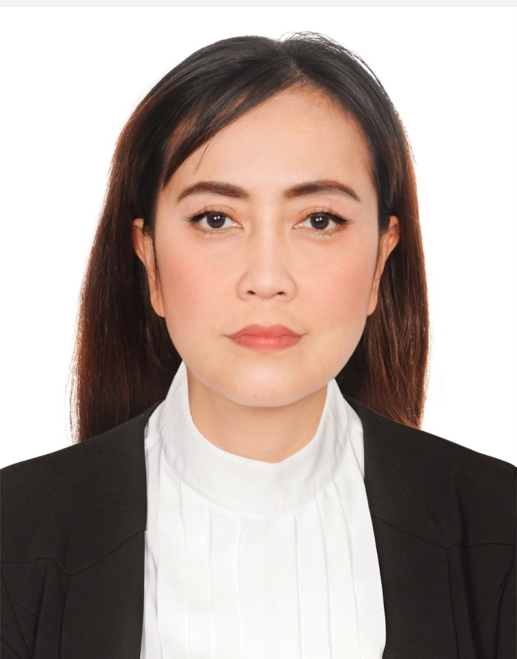
MARIA CRISTINA LOPEZ
Home Address: Salahuddin ,Deira Dubai
Email: mcflopez_12077@yahoo.com
Mobile number: 050-1871439

CAREER OBJECTIVES
To step up in a career that would enable me to utilize and master my skills, and at the same time acquaint myself with new techniques and information that would enable me to contribute to the company.

STRENGHTHS
- Good in sales transaction and customer service
- Flexible and highly adaptable,hardworking
- Good in analytical & interpersonal skills ➢ Strong passion for customer service
- Honest ,stable and reliable
- Open to change and eager to learn
- Experience in customer service
- Familiar in merchandise system

WORK EXPERIENCES

SALES PROMOTERS
Carrefour Hypermarket( May and June 2022)

TALIS APPAREL (FOR MEN AND WOMEN) Part time
Al Ghurair Mall ( December 2019 – April 30,2022
SALES AND CUSTOMER SERVICE
- Assist Customers
- Cashier
- Replenish stocks

THE BOMB COSMETICS ( Organic soaps made in UK) Part time with NOC
The Arabian Center (September 2019 to December 2019)
SALES ASSISTANT/ BEAUTY CONSULTANT
- Advice customers which products is good for their skin
- Assist customers and cashier
- Customer Service
- Monitoring and replenish stocks

LA MAISON DU SAVON DE MARSEILLE (Organic cosmetics made in France)
Part time with NOC (June 8 –September 23, 2019)
Dubai Marina Mall/ Dubai Mall
SALES ASSISTANT/BEAUTY CONSULTANT
- Assist customers
- Advice customers which product is suitable for their skin
- Cashier

.ORTOPEDIA (Medical Shoes for Children and apparel for men)
November 2012 – June 10, 2019
Dubai Festival City/ Dubai Mall/ IBN Batuta Mall
STORE IN CHARGE/SALES REPRESENTATIVE/MERCHANDISING/PURCHASING
- Assisting customers, cashier
- Responsible for monitoring stocks, merchandising
- Handling customer complaints, administrative works

AFRINA IRANIAN SWEETS (sweetshop/bakery café)
October 2009 –October 2012
Sharjah, Jumeirah, Al Mamzar
SALES ASSISTANT/MERCHANDISING/BAKER ASSISTANT/INVENTORY CLERK
- Assisting customers , cashier, waitress
- Responsible for transferring and receiving stocks to and from other branches
- Controlling disposed stocks, inventory, merchandising
- Chocolate and sweets desining, helper for the bakers

)MIXX OF FLAVORS BUFFET RESTAURANT
May 2007 – August 2009
Manila , Philippines
FOOD ATTENDANT/CASHIER
- Assisting customers needs and wants
- Cashier , responsible for monitoring and refilling foods for shafing dish

THE COPA BUSINESSMAN’S HOTEL
January 2002 – April 2006
Makati city, Philippines
FRONT DESK CLERK/TELEPHONE OPERATOR
- Check in and out of guests, handling customers complaints
- Providing good customer service , monitoring room atendant
- Handling PBAX system, handling safety box, connect guests calls

SPECIAL SKILLS
- With Certicate on Computer Training program (microsoft word ,excel, power point)
- Certificate in Caregiver( NC2) and Japanese Proficiency Language ➢ Flexible ,hardworking, can adjust in different working condition

EDUCATIONAL BACKGROUND

PHILIPPINE WOMEN’S UNIVERSITY
HOTEL AND RESTAURANT MANAGEMENT
Manila,Philippines (1994-1997)

PERSONAL INFORMATION

Date of birth : January 20 ,1977
Visa Status : Freelance visa

