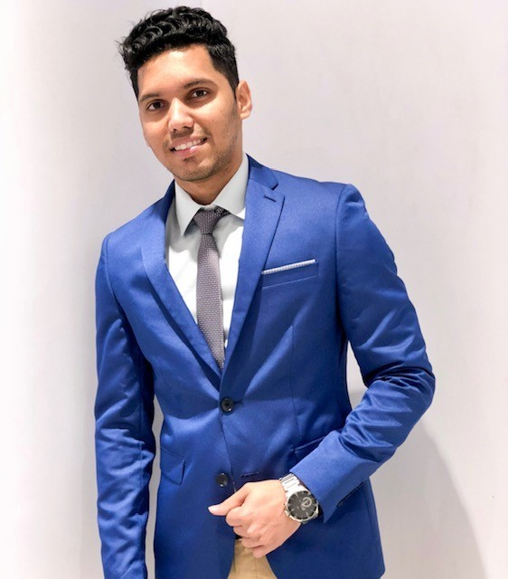
Professional Summary
Top-performing Retail Manager with +8 years of experience in Fashion apparel, leather goods, Client Handling and store operations. Successfully surpassed sales numbers and helped the store grow by 3% in region. Core responsibility being Team leading, Client handling, Improving CX, driving NPS/ CSAT and identifying business growth opportunities. Retail leader with successful track record in exceeding sales forecasts, generating repeat and referral business with customer centric mindset.

PREETHAM

Work Experience

SPLASH LANDMARK GROUP, OMAN
ASSISTANT STORE MANAGER

01/2016 - Present

SHETTY

Contact

Address
MUSCAT, OMAN

Phone
+968-99491596

Email
pritam.shetty42@gmail.com

Linked-IN http://linkedin.com/in/preetham- shetty06

Additional Skills

- Team Leading
- Customer service
- Client Handling
- Communication
- Achieved sales targets consciously by introducing customer centric service preposition.
- Experienced in managing stores above 40k sqm with team as big as 45 staffs of multiple nationalities. Exceeded expectations of top management in terms of smooth store operations and KPI achievements.
- As Asst. Store Manager in SPLASH, I am responsible for achieving the Sales and Profit goals by creating and implementing action plans to deliver a Great Customer Experience along with motivating the team in line with the Area
- Driving NPS and CSAT score and utilizing feedbacks to increase sales
- Training and motivating the staffs to drive business and achieve sales target
- Making sure the team members are following the grooming process, customer service steps & retail standards
- Ensuring corporate Visual Merchandising standards, store policies and guidelines are met

08/2014-12/2015
Lee Cooper, Future Group India
STORE MANAGER
- Responsible for the overall management of the store, VM, and customer service.
- Managing store staffs, ensuring team motivation and business involvement
- Improving customer shopping experience.
- Cash and store asset handling
- Responsible for maintaining sufficient inventory and to deal with best sellers and slow movers

06/2012- 05/2014
PETER ENGLAND, MADHURA FASHIONS
SENIOR SALES ASSOCIATE
- Have achieved sales numbers exceeding management expectations,
- Apart from standard sales responsibilities, have gone extra mile by handling cash counter and visual merchandising.
- Responsible for upkeep of department and customer service

MPHASIS, HP COMPANY INDIA
CUSTOMER SUPPORT OFFICER
01/2011- 05/2012


  - Handling customer calls and providing immediate solution
  - Making notes of the issues faced by customer on call
  - Taking complete details of the call on excel sheets

  - Providing complete solution to the customer through provided software thereby making sure complete customer satisfaction
  - Forwarding the calls to back-end in case of technical issues

Education

St. Aloysious Evening College, Karnataka
Bachelor Of Business Management Major in Marketing

Languages
English — Proficient

Hindi — Proficient

Arabic — Pre-Intermediate

Kannada — Native

06/2014

