G. POTHIRAJ, Mechanical Engineer  :mechraj1989@gmail.com  : UAE - +971 547252683  +971 563820546  : India - +91 9952730890 | 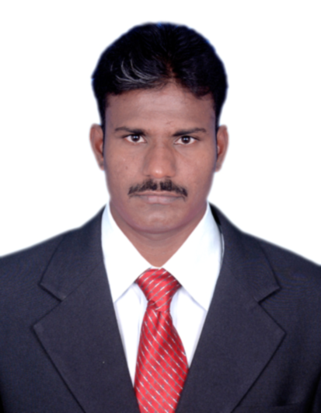
Summary of Experience

Seven years experiences in field work MEP construction, maintenance snag work and Inspection, Power Plant HDPE Construction, piping fabrication and Erection, steel structure, pipe inspection and Involved in various downstream and upstream project in India, and Dubai.
Having held previous position as an Piping Engineer, Supervisor various project/ company, also provided a strong technical knowledge and self-confident in performing any assigned responsibilities or duties in various Construction sector.
Education & Training

B.E (Mechanical Engineering)- MahaKavi Bharathiyar College of Engineering & Technology-2012
ASNT NDT LEVEL-II (RT / UT / PT / MT / VT)- Excel Institute of Technology- 2012.
ITI Fitter Serva Seva ITI - 2008
Computer kill: Auto CAD, Pro-E, MS-Office, Outlook.

Details Of Experience
1.Current Project
Company : Al Intilaq
Project : The Heart Of Europe
Clint : PSE Building Contracting
Designation : Mechanical Engineer
Duration : MAY 2020 to still

Responsibilities
- Generally responsible for implementations and monitoring of all mechanical related works at site as per approved drawings and methods and safety rules.
  - Estimates, prepares and assigns the resources such as manpower, materials, consumables, equipment, tools, etc., required for all Mechanical and related works prior to execution. Plans and analyses all possible construction methodologies and recommends the best options to the MEP Manager for approval prior to execution at site.
  - Interprets construction drawings and studies the contract documents and applicable standards or specifications prior to execution of any jobs.
  - Manages directly and provide engineering and technical supports to all the Mechanical work groups at site.
  - Plans the execution of all Mechanical related works and coordinates the works to Electrical and civil groups.
  - Assign targets for accomplishments and ensure targets are met on daily basis for all Mechanical groups at site.
  - Submits site daily reports, inspection requests, estimates and all applicable monitoring reports on regular basis or as required.
  - Submits site daily reports, inspection requests, estimates and all applicable monitoring reports on regular basis or as required.
  - Ensures that all the works done are in accordance with the approved construction drawings, contract documents, project specifications, and all applicable standards whether local, national or international standards. Able to lead site personnel to execute and completion of job on time at site . Performs other related duties as may be required by the MEP Manager.
2.Previous project
Company : Shams Al shuwahat plaster and tiles
Project : NEW AL AIN HOSPITAL
Clint : Arabtech Sanjose Joint Venture
Designation : Mechanical supervisor
Duration : May 2019 to Dec 2020

Responsibilities
- Manage and supervise the daily activities of the technical team and Daily morning has been taken HSE toolbox talk Awareness of work.
- Have been arrange the all materials and equipment’s
- Ensures optimal usage of manpower and resources. - Oversees and carries out maintenance and repair of equipment.
- Responds to all reactive maintenance within the specified service level agreements and operational policies.
- Have been collect the comments from QC Inspector and rectifying the comments.
- All the comments read carefully and give the instructions to workers
- The comments are Mechanical HVAC,Plumping, Electrical and Sub contractors works
- To be issue the comments to sub contractors and follow them.
- Setting goals for performance and deadlines in ways that comply with company's plans and vision.
- Monitoring employee productivity and providing constructive feedback and coaching.
- After complete the snag work to be rise the WIR to the QC team, and after inspection the comment from Clint to be rectified
- To be make the report solve the issues of water leakage from chill water, Plumbing, and fire fighting pipes
3.Previous project
Company. : Al Tareeq Al Saleem Tech & Contt . UAE
Project : Night Market & Board Walking, UAE
Client : VERGER DELPORTE UAE
Designation : Mechanical engineer
Duration : June 2016 – June 2018

Responsibilities

- Daily morning has been taken, HSE tool box and given awareness to get output,
- without incident and accident
- Have been arrange all Ducting equipment and tools, also manpower
- Has been clarify all drawing issue with client and get solution
- Each and every installations of duct has been follow with design and Procedure
- After installation has been finish, will follow test packages
- Responsible to check the testing setup and testing equipment
- Responsible to prepare data sheets of the conducted tests and results
- Follow the activity of MC, pre-commissioning and close punches
- To be make daily plan a day before the work start , according to project priority lines
- Support materials for Chanel, angle, beam, all support materials inspect.
- Inspection of Raw material & review of material test certificate.

4.Previous Project
Organization : Agro Welding and Engineering Works, (KKNPP 1&2 Site), India.
Project : Kudankulam Nuclear Power Plant, Tamil Nadu.
Client : Nuclear Power Corporation of India Ltd., (NPCIL), (2 X 1000 MV)
Designation : PIPING ENGINEER
Duration : June 2013 – May 2015

Responsibilities:

- Erection of TITANIUM,SS and CS PIPES for unit 1& 2 at Kudankulam Nuclear Power Plant
- Coordinate work teams directly in order to maintain high standards of performance.
- Checking all isometric drawing and GA Piping / field installation and establish the necessary logistics, Motivate workers to attain the production schedules.
- Monitoring progress and distribution of daily tasks, necessary tools and materials needed, with particular emphasis on compliance with specific safety rules and quality standards, ensuring the necessary logistics for each team of work
- before carry out test pack. Attend weekly med monthly analysis works progress.
- Pipe internal cleaning for small bore and large bore including jacket pipes Inspection of pipe fabrication and erection work.
- Identify the leakage area and plugging the leakage holes.
- Prepare the all documents and inspection the plugging holes
- Review of Material Test Certificates for Raw Materials like Pipes, Fittings, Flanges& Welding Consumables.
- Performing Incoming material inspection, verifying vendor’s material certificates in order to confirm as per project specification and relevant International Standards

Personal Information
Language knows : Tamil, English, Hindi, Malayalam
Nationality : Indian
Visa status : Investor valid up to 2022

Declaration
I hereby declare that the above mentioned information is correct up to my knowledge and I bear the responsibility for the correctness of the above mentioned particulars.

Pothiraj Gurusamy

