


000000000000000000006 Curriculum Vitae

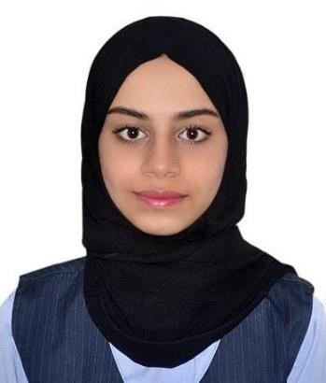

FATIMA MOHD YUNUS

United Arab Emirates (UAE), Dubai
Mobile :+971 50-2880021
E-Mail: bintmhmd2003@gmail.com

Career Objective:
A Suitable position with an organization where I can Utilize the best of my skills and abilities that fit to my Education, skills and experience a place where an encouraged and permitted to be an active participant as well vital contribute to development of the Company.

Personal skills:

- Hard working & Dedicated
- Honesty & Reliability
- Good communication & analytical skills ❖ Easy adaptability to situations.
- Self confidence
- Leadership Quality
- Quick learner & Trust worthy

Academic Records/Education Qualification:

- Grade 12 CBSE graduated from Gulf Model School (Dubai)

Computer Knowledge: -
- MS Office (Excel, Word & PowerPoint)
- Expert in Internet browsing & E-mails. ❖ Operating Systems: Windows 2000/XP/XP-7.

Work Experience:

- Worked in Dubai Book Fair
- Worked in webone as “telesales”
- Worked in Concerts
- Worked in Sharjah Expo as a “promoter”
Personal Details:

- Father’s Name : Mohd Yunus
- Date of Birth : 12th August, 2003
- Nationality : Bangladeshi
- Gender : Female
- Religion : Muslim/Islam
- Marital Status : Un-married
- Linguistic Ability : English, Urdu, Bengali & minor Arabic.

Declaration:

I hereby declare that the above details given by me are true and correct to the best of my knowledge, information and belief.

FATIMA MOHD YUNUS

