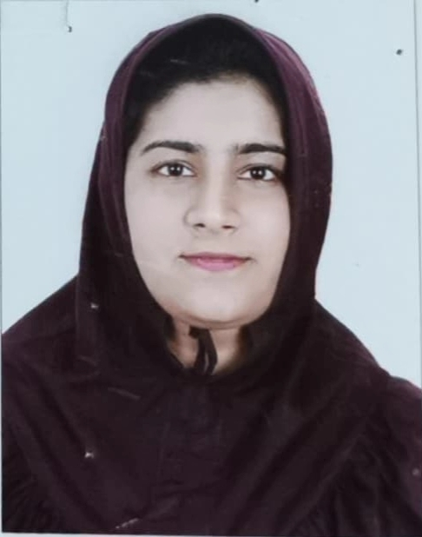
Zainab Khambaty
6 years of Customer Service Experience
Zainab.kht96@gmail.com
+971557069774
Dubai, U.A.E

SUMMARY

Active team player, ready to work in a multinational Company which offers a professional working environment and enables me as a graduate to grow while meeting Organization’s goal.

WORK EXPERIENCE

Emirates Islamic Bank - July 19 – Nov 2021
(Customer Service Representative)

- Attending Inbound and making outbound calls and assisting customers with their queries
- Answering customer queries via emails
- Raising necessary requests and complaints on call with the Customer.
- Providing customer satisfaction and minimizing frequent repetitive calls
- Escalating customers issue to Management in order to get quicker resolutions
- Generating Sales report for the Management
- Participating with Work Force Management

Data direct - Majid Al Futtaim – Nov 18 – April 19
(Customer Service Representative)
- Communicate with customers to solve problems. These problems include everything from complaints to simple questions
- Ability to Handle Difficult Clients.
- Calling customers for the events. In order to get many people as possible.
- Team Building & Leadership quality
- Time management skills.
- Manage upset customers, conflicts and challenging situations.
- Highly professional--dependable, reliable and able to perform duties with minimal supervision.

TP- Connects – July 18 – Oct 18
(Customer service Coordinator)

- Handling live issues related to the flights, hotels and car transfers.
- Providing help and advice to customers using knowledge of organization's products or services.
- Communicating courteously with customers by telephone and email.
- Investigating and solving customers' problems, which may be complex or long-standing problems that have been passed on by customer service assistants.
- Developing feedback or complaints procedures for customers to use.

Mashreq Bank – Nov 17 - May 18
Customer service & Sales

- Guide the customer in doing the ‘Card Transaction’ initiated by the cardholder were the Cardholder agrees to repay Mashreq in equal monthly instalment.
- Responsible for supporting all financial reporting needs of the department.
- Approaching customers and politely asking questions to understand their needs.
- Friendly polite and approachable.
- Accurate target setting & daily sales reporting in a way that highlights achievement & under-achievement.
- Promote the best value of the products for selling;
- Advantages of the product to 100% customers’ satisfaction.
- Work Involves guiding customers who are paying high interest on their Credit Cards from other banks, help them save money by simply transferring the balance onto their Mashreq Credit Card at attractive interest rates
- The role will focus on continuous improvement in all areas of customer interaction.

First Gulf Bank– (December 2014 – 2017 February)
Customer Relations & Cross selling agent

- Work Involves guiding customers who are paying high interest on their Credit Cards from other banks, help them save money by simply transferring the balance onto their FGB Card at attractive interest rates
- Selling Credit cards to the customers
- Very good Experience in cross selling and customers relations.
- Achieving daily targets and constantly increased sales.
- Well – versed in the insurance Field.
- Winning Customer Loyalty for Credit card through demonstrating Quality of the Product over the phone.

Simple Real Estate - September 2014
Admin/Sales Representative

- Handling effective paper work and advertisement (Dubizzle).
- Answer phone: handle basic questions, transfer calls as appropriate, screen for suspicious calls.
- Selling apartments and villas to the customers.
- Update customer records in the company database as required

Al Murtaza building materials – June 2014
Accounts Department

- A comprehensive Accounts management.
- Worked with al Murtaza building materials for three months.
- Prepared debit and credit statement.
- Sound Knowledge of Accounting.

EDUCATION

Madonna University, Dubai – 2017 – Grade 3.97 / 4
Bachelor’s in business administration (International Business)

Gulf Indian High School, Dubai - 2014
High School (Commerce Stream); 90%

Academic Achievement:

- Received Merit Scholarship for consecutive 3 years at Madonna University, Dubai
- School Topper in High school (2013 – 14)
- Active Participant of Debate, Cookery and Sports competitions in School.

SKILLS

- Sound Knowledge of Banking, Insurance & Finance Field.
- Poses Leadership Qualities and enjoy working with Team.
- Excellent knowledge of CRM, vision plus, banknet Account system, And Customer Connect.
- Ability to obtain and analyze Data.
- Proven Leadership skills & ability to motivate.
- Computer Skills:
- Proficient in MS Office (Word, Excel, Power point)
- Basic Knowledge of HTML
- Proficient Knowledge of Email and Internet.

PERSONAL INFORMATION

Nationality: Indian
D.O.B: 05/10/1996
Visa Status: Husband Sponsor
Driving License: Automatic (Light Vehicle)
Marital Status: Married
Languages Known: English, Urdu, Hindi, Gujarati, Arabic (Basic)

