CURRICULUM VITAE
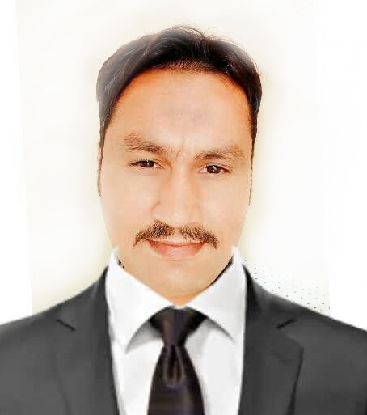

Tahir Kashan
Email Address: KASHAN4G@GMAIL.COM
Address: Sharjah/Employment visa
Mobile Number: 971586191456

- Objective:
I would like to implement and inflate my knowledge of the rapidly increasing technology in the globe. I believe that a well-establish organization could utilize the depth of my knowledge and experience to excel professionally in a competitive environment using aesthete skills to reach apex of success.

- Education:

- B.A from BZU (Multan Pakistan)
- F.A from BISE (DG KHAN Pakistan)
- Matric from BISE (Rawalpindi Pakistan)

- Computer Skills:
- MS.OFFICE 2000 & XP AND INTERNET
- WINDOW 95, 98, 2000, ME AND XP
- CORAL DRAW 9 AND INPAGE (URDU AND ENGLISH)

- Skills:
- Greet customers, make suggestions, answer and present the menu.
- Knowledge of detail brief with Customers reason of complain.
- Excellent Communicating skill as for possible in Customer Service.
- Ensure quality service in the dining room and serve meals. Prepare serve dessert.
- Team Handling
- Analytical and problem solving skills.
- Decision making skills.
- Effective verbal and listening communication skills.
- Computer skills including the ability to spreadsheet and word processing programs at a highly proficient level.
- Stress & Time management skills.

Organization: ETRAN INTERNATIONAL LLC du Channel Partner (UAE)
Designation: Senior Sales Executive
Tenure: Apr 2020 – Nov 2020
Generate qualify Customer who are eligible to use the services.
Controlling, correspondence reviewing and approving agents progress and supply requisitions assigning and monitoring agents conditions.
Leads generating through socail media and physical refrences.
Grow the reveneu of company by numbers of sales.

Organization: P7 Electronics LLC du Channel Partner (UAE)
Designation: Office Manager
Tenure: Apr 2019 – Mar 2020
- Maintains office services by organising office operations and procedures
- Controlling, correspondence reviewing and approving agents progress and supply requisitions assigning and monitoring agents conditions

Organization: Zain Telecom LLC du Channel Partner (UAE)
Designation: Sales Executive
Tenure: Sep 2018 – Feb 2019
- Strong negotiations skills
- Primary responsibilities build market position by locating, developing, defining, identify and build relationships with prospective customers through a verbal communications
- Maintains relationships with customers by providing sport, information, guidance and recommending new promotions with service improvements

Organization: Pakeeza Hotel & Restaurant (Pak)
Designation: Receptionist
Tenure: Feb 2015 – May 2017
- Welcomes visitors by greeting them on desk and over the phone
- Excellent written and oral communication abilities
- Strong negotiation skills
- Direct visitors by maintaining employee and department directories, giving instructions.
- Maintains security by following procedures, monitoring, issuing visitor badges.
- Friendly and pleasant voice.
- Answering and forwarding phone calls, keeping the reception area tidy.
- Checking guests in and out, issuing keys, taking reservations by telephone or email preparing bills and dealing with payments
- Excellent record-keeping and data entry skills

Organization: Al Fursan International (Pak)
Designation: Customer Relation Officer
Tenure: Nov 2012 – Dec 2014
- Proficient with computer spreadsheet and Microsoft office
- Excellent written and oral communication abilities
- Strong negotiation skills
- Friendly and pleasant voice
- Full fills requests by clarifying decide information, completing transactions and forwarding requests
- Determines requirements by working with customers
- Excellent record keeping and data entry skills

Organization: Zaitoon Hotel & Restaurant (Pak)
Designation: Staff Supervisor
Tenure: Apr 2010 – Aug 2012
- Direct and supervise work of personnel engaged in food preparation and serving duties within a restaurant rules.
- Responsible to manage the staff and maintain their duties on the shift
- Interact with customers to make sure that they have a satisfactory experience.
- All related works about supervise to maintain the services and targets.

Organization: A Plus communications (Pak)
Designation: Customer service Representative
Tenure: Jan 2007 – Dec 2009
- Answers enquiries by clarifying decide information, Researching, Locating and Providing information
- Resolves problems by clarifying issues, exploring answers, alternative solutions, implementing solutions, escalating and unresolved problems.
- Determines requirements by working with customers

- ACHIEVEMENTS:

- Learn best level of administration and customer service skills.
- In career maintain excellent written and spoken communication skill.
- A friendly and professional telephone manner patience and tact.
- Extract the ability to stay calm under pressure and look after several things at once.
- Interact well with Diverse Cultures l Groups Knowledge of Community Resources.
- Research and Planning, Critical Thinking, Resolve Conflicts l Counselling.
- CUSTOMER SERVICE REPRESENTATIVE

- PERSONAL DETAILS

NAME: Tahir Kashan
DATE OF BIRTH: 01-04-1981
RELIGION: ISLAM
NATIONALITY: PAKISTANI
ADDRESS: SHARJAH U.A.E
LANGUAGE: ENGLISH, URDU, and Punjabi
References: WILL BE FURNISHED IF REQUIRED

