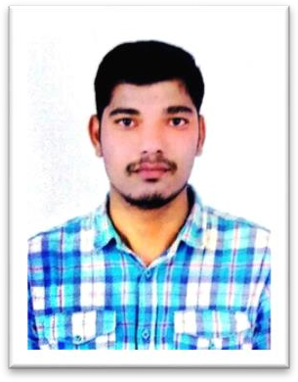
CURRICULUM VITAE

MOHAMMED MATEEN
Contact No: +91 8880889031
EDUCATION QUALIFICATION

Qualification : International Public School
Board Name : Karnataka Secondary Education Board, Bangalore Year of Passing : 2014
TECHINAL QUAIFATION
Qualification : Diploma in Mechanical Engineering + HVAC Board Name : B.T.E Bangalore education
Year of Passing : 2019
WORK EXPERIENCE

- 3 Month Experience in automobile industry at pune

PERSONAL ABILITIES:-

- Ability to work in teams as well as individual
- Ability to negotiate and motivate
- Skilled in communication
- Good organizer with knowledge of efficient planning and time management.
PERSONAL PROFILE:-

To give my best in whatever I do. Appointment in an organization of repute, professionally managed and having target oriented work culture, which will provide career growth along with job satisfaction

PERSONAL DETAIL:-
Name : MOHAMMED MATEEN
Date of Birth : 01/04/1998
Father’s name : ABDUL AZIZ
Gender : Male
Marital Status : Unmarried
Languages Known : English, Kannada, Urdu Nationality : Indian
Permanent address : H.NO 7-271 Mominpura Sadar Mohalla Gulbarga

DECLARATION:

I hereby declare that the information furnished above is true and correct to the best of my knowledge and all the testimonials in regard to the above will be presented personally.

Place : GULBARGA
Date:
(MOHAMMED MATEEN)

