CURRICULUM VITAE
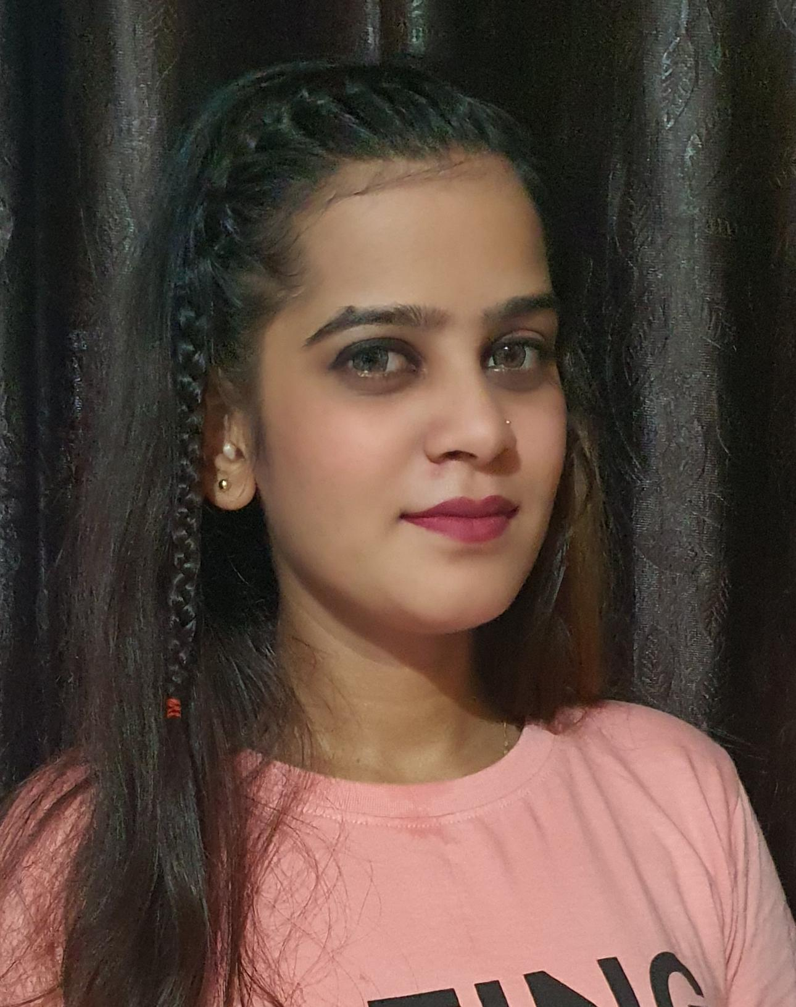
JYOTI SINGH
Mobile: +91-7710844218
E-Mail: JASMINE.SINGH2402@GAMAIL.COM

Career Objective:

To work in a growth-oriented organization and to employ the knowledge and skills acquired during study and professional career to contribute to the team effort to achieve group goals and at the same time endeavor to acquire newer and sophisticated skills as they come.

Educational Profile: -
Education | School / College | Board / University | Year | Division / Class
B.A. | Rastriya Vishwa Vidyapeeth University | Maharashtra Board | 2015 | Distance learning
H.S.C. | R.J. College | Maharashtra Board | 2009 | Regular
S.S.C. | Secondary high school | Maharashtra Board | 2007 | Regular

Experience Profile: | Total Experience Approx. 8 Years.

- Company Name: Maple (Apple authorized Reseller)
Designation : Apple consultant
Duration : September 2020 to present

- Company Name : William grant’s & Son’s (Mumbai International Airport)
Designation : Brand Ambassador
Duration : may 2019 to september 2020

- Company Name : Adidas (Mumbai international Airport)
Designation : Sales executive
Duration : Sept 2016 to Nov 2018

- Company Name : Suriti the culture shop( Lakewood mall Pvt. Ltd-group of Hiranandani)
Designation : Customer care executive
Duration : April 2010 to till Dec 2013

Additional Experience in promotion

- Company Name : Pernod Recard (International airport)
Designation : Brand Promotion
Duration : December 2018 to January 2019

My Job Discription
• Able to maintain high standard of display& visual merchandising to
ensure the store is well presented
• To suggest the fashion to the customer about new trend
• To achieve the daily individual sales target
• Always smartly dressed, articulate and presentable
• Experience of working in a commission-based sales environment
Ready to help customer what they want
• Sales and good numerical skill with manually calculate costs without error
• Willing to work on a shift basis including evening and weekends
• Able to accurately describe a product features and benefit to a customer
• Ability to take ownership of issues and to work Alone with little or no
supervision.
• Operating cash counter(Billing)
• Stock inward and outward
• Ensuring correct Cash and card to be recorded and send to accounts
department.
Personal Profile
Passport No. : P6790305

Date of birth : 24-02-1992

Nationality : Indian

Sex : Female

Marital Status : Single

Language Known : Marathi, Hindi, English.

Address : om Shiv Shakti society, Varsha nagar,NL nalanda balwadi Park site. Vikhroli west. Mumbai – 400079.

Declaration : - I hereby declare that the information furnished above is true to the best of my knowledge and belief.

Date: Signature

Place: ( Jyoti Singh )

