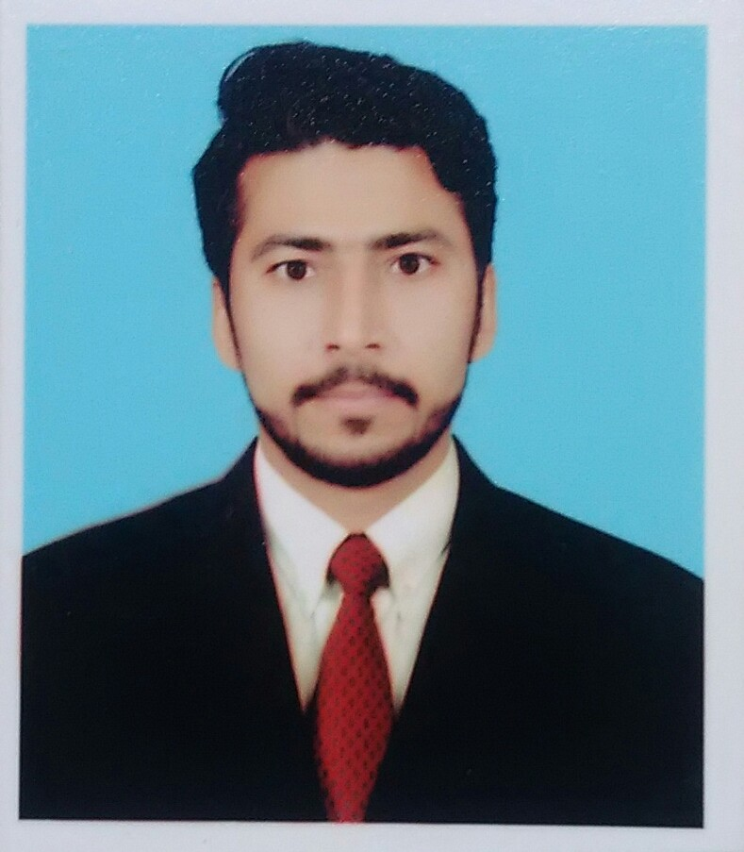Curriculum Vita/Resume
Muhammad Jahangir

Data Processing Officer Present Address: Near Tabligi Markaz,
Muller & Phipps Pakistan Pvt Ltd. D Block Makki Town, Badu Road,
2nd floor Sikander Plaza, Near Royal palace, City Sheikhupura, Punjab Pakistan.
Lahore road Sheikhupura (Unilever Business) Cell#0301-4642567, 03447870572
Phone# 056-3501073

OBJECTIVES
My prime objective is to build a career with a progressive, dynamic and well reputed organization offering good opportunities and challenging working environment to improve my knowledge, experience and capabilities.
EDUCATION:

- Bachelor degree in Arts & Economics Allama Iqbal Open University. (2012/2014)
- Intermediate of Arts & Economics BISE Lahore.(2009-2010)
- Matriculation (Science) BISE Lahore.(2007-2008)

Training Courses:

- Six Month Basic Computer Course (CCA).
- Six Month Course in Electrician.
- Three Month Course in Freelancing.
- Three Month Course in Digital Literacy.

EXPERIENCE:

Data processing officer: (Dec 2016 to date)
MULLER & PHIPPS. (UPL Sheikhupura)
Responsibilities:
- Control & Operates Unilever Software’s (Ultra & Lever Edge)
- Control & Operates M&P Software’s (Salezman, ZNI & Next)
- Principal Claim Processing & Generating Auto Claims.
- Data Entry in Company Software’s & Excel Sheets.
- Reporting to Local Team and Head Office Team.
- Sorting and distributing incoming mail and prepare outgoing mail.
- Warehouse Audit and Reporting.

Process Checker & Clerk: (July 2012 to Dec 2016)
Panther Tyre (PVT) LTD Sheikhupura.
Responsibilities:
- Control Quality Process & Check Quality Parameters.
- Maintaining files and records so they remain updated and easily accessible.
- Data Entry in Excel Sheets.
- Reporting to Local Team & Managements.

PERSONAL PROFILE

- Ability to work in a team and to lead
- Good written and verbal communication skills
- Customer Service Orientation
- Decision making, Listening, Multi-tasking
- Self-motivated and easily adopt changes
- Ability to work independently in remote locations

INTERESTS & HOBBIES:

- An urge to do something for Pakistan
- Travelling experience to various cities within Pakistan
- Listening to music and watching movies.
- Book Reading
- Internet Searching
- Cricket

PERSONAL INFORMATION:

Father’s Name : Muhammad Shafique
Date of Birth : 02-February-1990
NIC # : 35502-0147519-5
Domicile : Nankana Sahib (Punjab)

Nationality : Pakistani
Languages : English, Urdu, Punjabi
Marital Status : Married
Contact #. : +92301-4642567, +92344-7870572
E-mail : jahangir.athwal@gmail.com
Permanent address : P.O box khas, Thothian Kalan Chak# 10, R.B,
Tehsil Shahkot, District Nankana Sahib.
REFERENCES
Will be furnished on demand.

