CHUKWU,NNEOMA MABEL 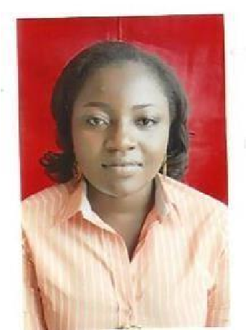
Mobile: +971 527002457
Email: callmabel2000@yahoo.com
Address: Al Nahda, Sharjah UAE
HEALTH CARE ASSISTANT
Objective
A dedicated entry level CNA, compassionate and positive individual with a team minded attitude and passion for patient care. To obtain a position of diverse clinical practice and also contribute to the growing health care field in patient care and handling.
Personal information

Nationality: Nigerian
Passport No: A10179397
Date of birth: 10th March 1989
Civil status: Married
Gender: female
Visa status: Long time visit visa
Language: English
Working Experience
- 03 years experience as a Healthcare Assistant with Cova Care Specialist Hospital and Endoscopy Nigeria (2018 – 2021)
- 04 years experience as an Administrative Officer with Paschal Technical services LTD (2015 -2018)
- 1 Year NYSC experience as a Class teacher with Community secondary school elelenwo Port Harcourt (2014 – 2015)
- 1 year work experience as a Customer service officer with Sulan services Ltd (2013 – 2014)
Educational Attainment:
CNA Certified Nursing Assistant training and exam prep with certification accredited by the American Medical Association at Strong Point Educational and Training institute ( KHDA approved) in Dubai.
First Aid and CPR certified
B.A ( Mass communication)

Personal Skills: Understanding patient care, safety and handling. Ability to handle stressful situations. Effective communication skills. Keen observational skills. Physically fit with abilities to operate long hours and also patient handling and moving. Organized in collection and documentation. Cultural awareness.
Declaration: I hereby certify that all of the information supplied herein are true and correct to the best of my knowledge and belief.

