CURRICULUM VITAE

Summary Of Qualifications
- Answer phone an email inquiries from potential guests in a timely and respectful mannerKnowledge in Opera System
- Greet guests and visitors warmly and make them feel welcome and attended
- Offer restaurant and activity recommendations and assist guests in arranging transportation and excursions
- Receive and redirect mail, phone calls, packages, etc.
- Ensure that guest spaces and lobby are clean and tidy at all times
- Anticipate guest’s needs in order to accommodate them and provide an exceptional guest experience.
- Maintain inventory of supplies and order new stock as needed.

Objective
I am seeking an opportunity as Concierge Supervisor to show my abilities for achieving absolute satisfaction from guest and contributing to the growth of the company. I have relevant experience in the hospitality industry, as well as customer-related service, and streamlining service procedure.

Work Experience

Lapita Autograph Collection DPR (504 Rooms), Dubai, UAE.

Concierge Team leader Pre-Opening From October 2016 Until Present.

Rotana Hotels & Spa Sharm El Sheikh, Egypt.
Bell Captain From December 2010 Until January 2013.

Louis Hotels Sharm El Sheikh, Egypt.
Bell Captain From February 2010 Until November 2010.

Sonesta Taba Hotel, Taba Egypt.
Shift Leader Bell Desk From November 2008 Until December 2009.

Tropicana Grand Oasis Hotel Sharm El Sheikh, Egypt.
Bellman from March 2006 Until October 2008.

Mostafa Said Deyab Ismail
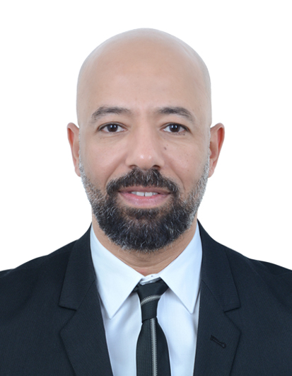
PERSONAL DETAILS
Date of birth :1st May 1977

Gender :Male
Religion :Muslim
Nationality :Egyptian
Status :Married
Education :Bachelor
Address :Discovery Gardens St,8
Bulling 163, Dubai, UAE

Contact
Telephone : +971544626631

Skills
Computer Literate
MS Word  MS Excel  MS Power Point  Internet  Photoshop 

Language
Arabic 
English 
Russian 
Italian 





Email : mostafasaaid14@gmail.com







Training Expertise

1- American Hotels & Loding Educational Institute.
2- Fire Training.
3- First aid Training
4- Certificate by Director Of Learning & Development
5- Certificate of Guest Contact Skill

