TIJITH K SASI
B. Sc NURSE;
RN,(HAAD)
EXPERIENCE:9 YRS

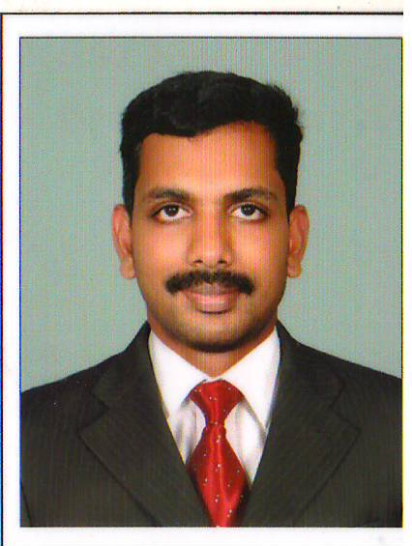

Address:
NMC SPECIALITY HOSPITAL
ELECTRA STREET
AIRPORT ROAD
ABUDHABI
PO BOX 6222

✆/ 🖂
+971527179376
+971566364177
+919745543033
tijithksasi@gmail.com

DOB: 01 May 1987
PASSPORT DETAILS:
No: K4362034
Place of issue: TRIVANDRUM
Issue date : 04/06/2012
Expiry date: 03/06/2022

Nationality: INDIAN

Profile

HAAD REGISTERED NURSE

- EDUCATIONAL PROFILE
- SSLC, Board of Public Examination, Kerala (2002).
- Plus Two, Board Of Higher Secondary Examination, Kerala (2004).
- B Sc Nursing, Rajiv Gandhi University of Health Sciences, Karnataka (2008)

Professional Experience

- Hospital : FORTIS HEALTH MANAGEMENT
(NORTH) NOIDA
Country : India
Duration : Dec-2009 to Mar-2012
Designation : Senior Staff Nurse
Department : CTVS ICU

- Hospital : NMC SPECIALITY HOSPITAL
ABUDHABI
Country : UAE
Duration : OCT-2012 to TILL DATED
Designation : Registered Nurse
Department : MICU+CTICU

Professional Affiliations

- HAAD REGISTERED NURSE (GN15610)

- Registered with the Karnataka State Nursing Council Reg No: 14865.
- International Trauma Life Support Provider Advanced Cardiovascular Life Support provider and Basic Life Support Provider Certification from American Heart Association.

JOB DESCRIPTION
- Assessment ,Monitoring and care of patients with Acute Coronary Syndrome
- Care of patients Pre and Post CABG, Valve repair and replacement
- Care of patients with correction of congenital anomalies
- Care of patients With Severe Left Ventricular Dysfunction
- Assessment and care of patients with Acute STEMI and Non STEMI
- Thrombolization therapy for acute MI with tPA
- Performed Cardiopulmonary Resuscitation according to ACLS protocol
- Assessment, monitoring and care of Patients post Coronary Reperfusion(PTCA)
- Care of patients on Intra Aortic Balloon Pump Support
- Care of Patients with Tachyarrhythmia’s(Provided vagal maneuvers, Chemical and DC Cardio version)
- Care of Patients with Bradyarrhythmias(Provided medication, Transcutaneous Pacing and Assisted in Temporary transvenous pacemaker insertion)
- Assisted in Emergency pericardiocentesis.
- Care of patients post Permanent Pacemaker
- Care of patients on Mechanical ventilation
- Induction ,monitoring And Care of Patients On Therapeutic Hypothermia
- Assisted for Endo-Tracheal Intubation, Tracheotomy, Central Venous Catheterization, thoracentesis and Chest Drainage .
- Dialysis care
- Tracheostomy care
- Colostomy care
- Participated in performance improvement activities.
- Coordinated age specific care for the adolescent, adult and geriatric individuals.
- Implemented Quality Assurance and practiced Infection control policies.
- Provided patient care utilizing the Nursing Process.
- Collaborated with the interdisciplinary team and coordinated patient’s plan of care.
- Maintained involvement in activities aimed toward the achievement of unit and the Department of Nursing strategic goals and objectives.
- Cared and monitored progress reports of the patients.

EQUIPMENTS AND SYSTEMS HANDLED
Hospital Information System (HIS) ,PACS,
ICU Ventilators (Maquet Servo, Siemens, Dagger, Puriten bunnet, ) , BiPAP units, Infusion Pumps, Syringe Pumps,
Patient Monitors(Phillips Intellivue MP40),, Defibrillators, ECG machines , ABG Analyzers ,
Temporary Pace makers (Medtronic 5348,5388), Intra Aortic Balloon Pump(Datascope).

STRENGTH
Sound knowledge of CCU ,CTICU and Critical Care procedures and medications.
Effective organization, prioritization, time management and problem-solving skills .
Remarkable ability to function under stress and emergency situations, critical thinking abilities .
Ability to function independently,delegatory and in a team and goal-oriented .
Effective Communication and Leadership Skills

Declaration:
- All the information in this document contains the truth and is written to the best of my knowledge.

Place: ABU DHABI TIJITH K SASI

