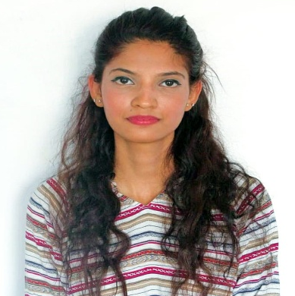Ujala Saher  CONTACT  +971-569275450 ujala.saher28@gmail.com  Address: Flat # 203, 2nd floor, Al Asmavi Building, Al Barsha 1, Dubai  PERSONAL INFORMATION  D.O.B: 28, June, 1997  Nationality: Pakistan  Passport#: EE5121572  Visa Validity: 16.01.2021  PROFILE  I want to work in a politics-free environment; work-load has never been a issue for me. A company where every task is well performed, responsibilities are disturbed accordingly and each member gets a changes to improve every day. I would like to work in a company/ organization where I can grow.  SKILLS  Show up on time every day (punctual, reliable, dedicated) - Work well under pressure (resilient) - Professional Fast team environment (team player) - Positive Bubbly Friendly Attention to detail (detail-oriented) - Speed - Accuracy - Follow through Multi-tasking - Effective listening - Follows directions - Experienced - Knowledgeable - Multi tasking  SOFTWARE  MS Word - MS PowerPoint - MS Excel - Adobe Photoshop – SPSS  CONFERENCES  Leaders' Expo – 2013  Head Social Media, IUMUN-2019  COURSES  MS-Office & Hardware and Software – 2013  REFERENCES  Available on request. |  | WORK EXPERIENCE  Customer Support Executive @ Food panda (APAC). IBEX TRG, Karachi, Pakistan.  March 2020 – October 2020  - Responds to customers' questions received through the live Chat/ Email.  - Investigate and resolve customer complaints and resolve complaints quickly and patiently.  - Resolves product or service problems by clarifying the customer's complaint; determining the cause of the problem; selecting and explaining the best solution to solve the problem under company policy. Communicate and coordinate with the internal department.  - Accurately update customer information into CRM software.  - Provide feedback on the efficiency of the customer service process.  - Marinating excellent CSAT, AHT, and QA Score.  Coordinator, International Programs @ Iqra University, Karachi, Pakistan.  April 2018- August 2019  - Coordinating exchange programs  - Faculty exchange programs, Research programs  - Online sessions, etc with countries across the world  - Answering all forms of inquiries from prospective students and parents  - Building excellent working relationships with International Universities via telephone, email, and face-to-face communication.  Admission Officer @ Iqra University, Karachi, Pakistan.  January 2017- April 2018  -Analyze the applications of prospective students based on standard admission policies.  -Interview students to understand their objectives and background.  -Provide clarifications to student’s queries in a professional manner.  -Follow-up with students for any inquiries through direct meetings, phone calls and emails.  -Advice students about the programs offered, admission procedure, eligibility, and costs involved.  -Provide assistance with recruitment activities, student interviews, admission publications, and information sessions.  -Provide assistance to the students to complete the enrolment forms.  -Review all the students’ applications and refer the students to financial services personnel if required.  -Inform students about the courses offered and the tuition fees.  -Arrange orientation programs, educational workshops, and graduate programs for students.  -Provide support to prepare admission related presentations and to host student receptions.  -Develop innovative communication strategies, recruitment strategies, and enrolment plans in coordination with senior management to attract and enroll more students.  -Participate in all recruitment events, open houses, school fairs, information sessions, exhibitions, School visits, and off-campus events.  -Maintain a database of student information, telephone logs, and student feedback's in order to generate student reports for management whenever required.  -Provide support to the Senior Admission Counselor when needed.  Internship, Admission Office @ Iqra University, Karachi, Pakistan.  May 2016- January 2017  EDUCATION  Bachelor of Business Administration – Iqra University  2016 – 2019  Intermediate – Trinity Methodist Girls Higher Secondary School  2013 - 2015  Matriculation – St. Paul’s English High School  2001 – 2013  CERTIFICATES  Pakistan International Film Festival (PIFF) - 2018  Job fair & Start-up Expo - 2018  Innovation Camp - 2018  Self Defence Event - 2018  Run for Karachi'23 – 2017  IUMUN - 2017  Global Entrepreneurship Week - 2017  Employability Week - 2016  Internship – 2016  Web Designing - 2013

