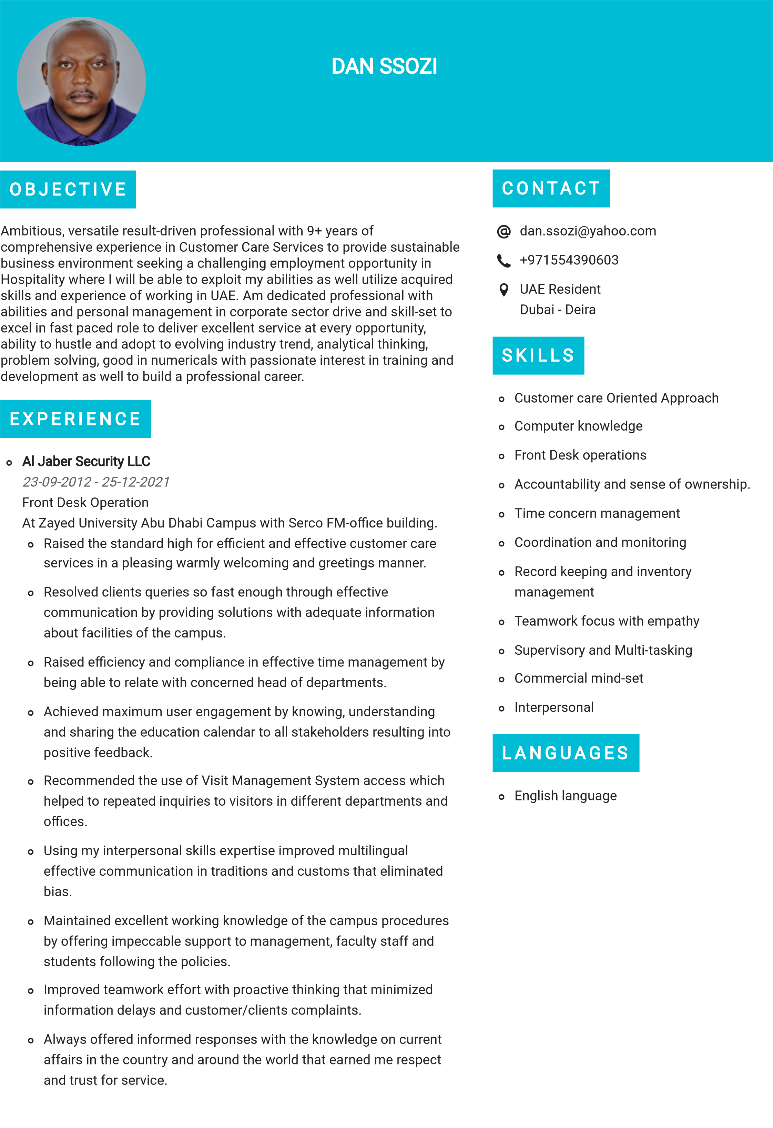
Mukwano Industries Ltd Kampala Uganda
3/02/2010 - 5/11/2011
Administrative Assistant
At Crown Plastics industry.
Improved smooth operations by managing office space and maintaining office stationary inventory by restocking supplies and placing purchase orders in time.
Assisted with clerical duties along with recording keeping and filing, prepared packages for shipment, pickup and received courier deliveries for senior management staff.
Gathered enough information and created Excel spreadsheets outlining performance that resulted in effective recording tracking and data communications.
Maintained detailed administrative and procedural processes to improve accuracy and efficiency of office operations.
Oversaw staffcorrespondences, financial documents including contracts, expense reports and invoices that Improved accuracy and efficiency.

EDUCATION
Makerere University
2009
Bachelor of Business Administration
2.75 CGPA

