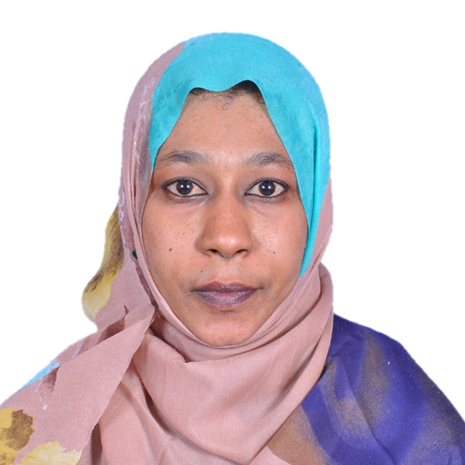EKRAM AZRAG
IT PROJECT COORDINATOR
Ekunna2011@gmail.com · United Arab Emirates · mobile: + 791 502189895
My professional experience in information technology projects coordinator with +6 years’ monitoring and managing communication for technical project processes between the technical and business functions of the organization.

Seeking an opportunity utilize, showcase and expand core competencies interpersonal relations, communication skills, solve problems, creative and initiative.

Experience

FEB 2020 – feb 2022

it project coordenator, national university
Gather and analyze facts, draw conclusions, define problems, and suggest solutions.
Develop, maintain, update, and oversee project plans and schedules using tools established by agency and division.
Monitoring and maintaining project plans, schedules, work hours and budget.
Provide technical assistance to management and Technical Project Managers in request management, project prioritization, resource allocation, and regular portfolio reviews.

aug 2015 – dec 2019

it project coordinator, aliaa specalist hospial
Create a project management calendar for fulfilling each goals and objectives.
Coordinate plans and systems, set priorities project deadline. Collect and evaluate project data necessary to meet project reporting and evaluation requirements.
Design and develop the configurations to be deployed on systems using the approved solution assessment to meet customer requirements.
Oversee the work of professional Information Technology staff by making and reviewing work assignments, establishing priorities, coordinating activities, and resolving related work problems
Implement IT concepts and basic operating principles of data communications and information systems hardware and software.
maintain records, prepare reports, and conduct correspondence related to the work.
Documentation for each projects.

JAN 2008 – JUN 2015
SYSTEM ADMIN, SCABS ENGINEERING COMPANY
organize, install and support an organization's computer systems.
troubleshoot system and network problems, diagnosing and solving hardware or software faults. Test and evaluate new technology.

JAN 2005 – DEC 2007
DATA CENTER SUPERVISOR, MINISTRY OF INTERIOR AFFAIRS
Responsible for main server to print passports and IDs. Reviewing and verifying of the data entered by data entry, printing it and setting a date for its delivery to the customer.

DEC 2004 – DEC 2005
DATA ENTERY, NATIONAL INFORMATION CENTER
Enter passport, nationality and IDs data.

Education

DEC 2010

MASTER DEGREE, UNIVERSITY OF KHARTOUM

COMPUTER SCIENCE.

JAN 2004
BACHELOR DEGREE, OMDURMAN AHLIA UNIVERSITY

COMPUTER SCIENCE.

FEB 2009

DIPLOMA DEGREE, SUDATEL TELECOMMUNICATIONS ACADEMY
COMPUTER MAINTENANCE AND NETWORK

Skills
- Proficient using Microsoft office software.  - Excellent communication skills.  - Good skills in social media marketing.  - Multi-tasking. | - Good Time and project management.  - Excellent Make plans and strategic.  - Working effectively both independently and as part of a team.

