CURRICULUM VITAE

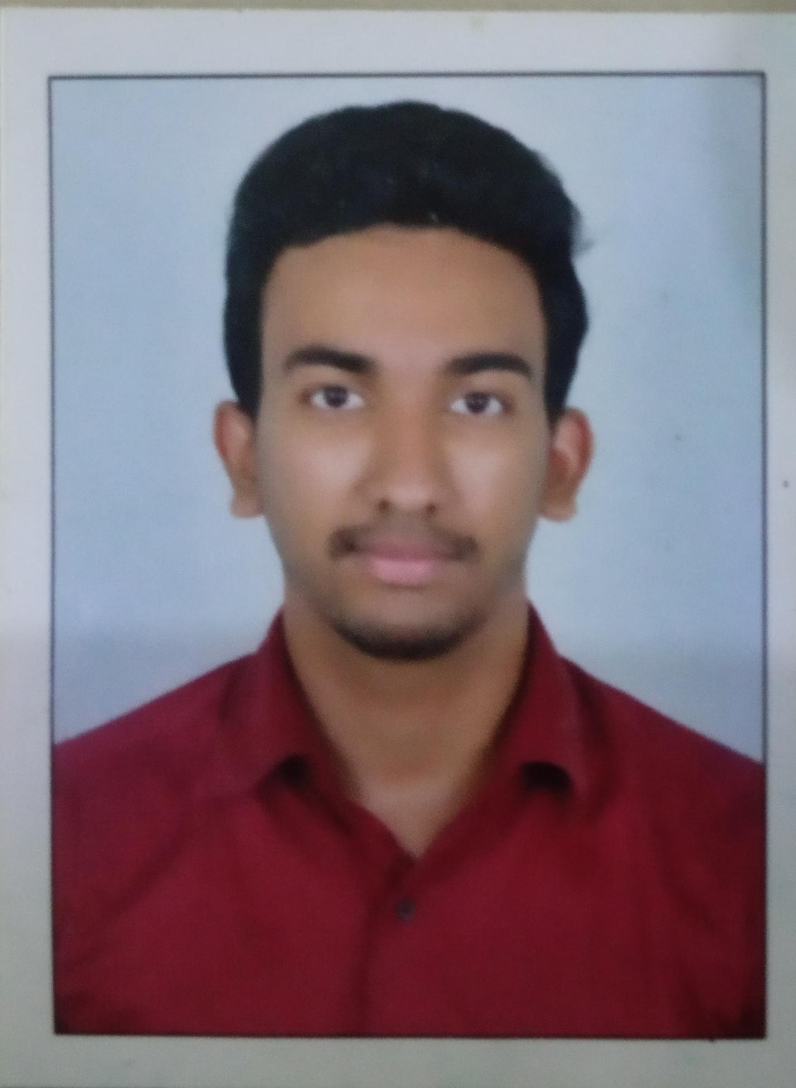
JERRIN DANIEL

408, GOYAL AVENUE NIPANIA

INDORE 452010 MP

Mob:+917558901849 +917771065147

E-Mail: JERRINDANIEL777@GMAIL.COM

CAREER OBJECTIVE

To combine my skills, education and experience in a responsible and challenging position with a professional organization offering continuous growth and advancement opportunities.

PROFESSIONAL STRENGTH

- Positive attitude and hard work
- Can work under skill pressure environment
- Quick adaptable to changes
- Possess a good communication and interpersonal skill

EDUCATIONAL QUALIFICATION

B.C.A | MS UNIVERSITY THIRUNELVELI | 2018
+2 | KERALA BOARD | 2015
S. S.L.C | KERALA BOARD | 2013

Other Educational qualifications

Completed Bachelor Of Computer Science (BCA) In 2018

INTERESTS

- Playing Cricket
- Cooking
- Listening Music
- Watching Movies
COMPUTER SKILLS

- MS-Excel/Word
- Browsing
- Tele calling
- Non Voice

Work Experience
- 6 Months In Teleperformance
- International Process Du (Dubai telecom)
- 24 Months in Continuum Global Solutions As Intent Analyst (Currently Working)

PERSONAL DETAILS

Father’s Name : John Daniel
Age : 24
Date of Birth :17 January 1997
Gender :Male
Marital Status :Unmarried
Religion :Christian
Nationality :Indian
Languages known :English, Hindi, Malayalam

DECLARATION

I hereby declare that all the above information are true and correct to the best of my knowledge and belief.

Place: Indore
Date: 11/13/2021 Jerrin Daniel.

