Mr. Driss El Abdellaoui
Captain / F&B
Current Location: Ras Al Khaima, UAE
drisselabdellaoui2@gmail.com +971-544-691-076

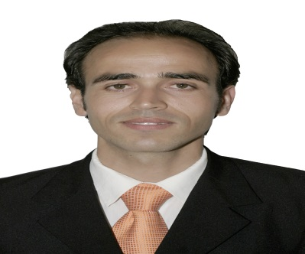


Profile Summary

- To achieve excellence through hard work, passion, exceptional people skills and a determined personal commitment toward my employer, work with the best companies and the first provider of finest personal service and facilities to customer. And continuously seek opportunities to innovate and improve my carrier and the company experience


Education

- 2004-2005 : Baccalaureate degree in literature Fez -Morocco
- 2007-2008 : Bachelor Graduated in Law Fez -Morocco
- 2008-2010 : PHIDI-Private Hotel Industry Institute-Management Degree Fez -Morocco


Soft Skills

- Good knowledge and experience in Microsoft office (Word, Excel, & PowerPoint…)
- POS Micros, restaurant reservation system Respak
- Productive and efficient work habits without supervision.
- self-confident, able to work well under pressure and in fast-paced environment, highly
Motivated and takes initiation.
- Ability to understand guest inquiries and provide responses
- Ability to focus on guest needs, remaining calm and courteous
- Ability to think clearly quickly and make concise decision
- Ability to work well under pressure in high occupancy
- Sense of responsibility
- Astute time management


Achievements & Training

- Food Hygiene
- Fire & Safety
- Customer Delighting
- Telephone Etiquette
- Be My Guest
.


Personal Details

.
- Date of Birth: 29th Feb 1988.
- Languages Known: English, Arabic and French.
- Permanent Address: Rakia Accomondation A6 Ras al khaimah
- Nationality: Moroccan
- Marital Status: Single


Work Experience

Captain / Rixos Bab Al Bahr July 2016 – Present

Al Marjan Island , Ras Al Khaimah , U.A.E
Department: F&B.

Resolving the guest problems ,engaging with costumers ,explain the menu to the guest a singing responsibilities and side duty's to the team , making the section allocation For staff ,following the standard of safety and security, check the cleanliness of the floor and back areas , double check the set up , cooperation with supervisor, manager and other department Following the rolls and the communication between staff and manager of the restaurants.

SPA Receptionist / Six Senses Spa Doha March 2015–December 2015

Doha , Qatar
Department: SPA

- Making Booking By Telephone or by E-mails, Welcoming the guest upon their arrivals using their names by nice smile giving them and provide them a glass of water or fresh towel , Check in the guest and escort them to common lounge ,Check out the guest and ask them the method of payment and ask if they can give their feedback ,Making report and all the task given by management ,up selling retail shop by suggesting the product for guest confirming The booking in the system After calling the guest and requiring them if they are coming for treatment or they will cancel , and inform the therapists if any changes in the timing or rooms for treatment
.

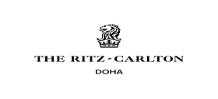
Bar Tender / Ritz Carlton Sharq Village & Spa January 2014 – March 2015
Doha , Qatar
Department: F&B

Making mise en place ,Make all type of the juices accordingly the guest request, Mixing alcohol and preparing all kind of beverages either alcoholic or nonalcoholic beverages, Ensuring all the guests receive their drinks and food as requested, Maintaining the cleanliness of all equipment using during shift ,Maintaining the cleanliness of the bar, store and refrigerators, to health, safety and hygiene standard all the time , Ordering all the food and beverages items needed in the restaurant And using first in first out , Maximizing revenue by up selling, and increase average spend per person.

Waiter / Royal Mirage August 2010– January 2014
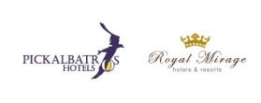
Fez, Morocco
Department: F&B

Greeting customers, escorting them to the table, pulling the chairs always lady's first presenting menus, and informing the guest about daily special ,Before the meal answering questions about menu items, and make suggestions if the guest asks , taking orders and deliver the orders to the kitchen, typically and requested beverages are served immediately ,During the meal, once the guest orders are ready, delivering the food to the table, returning a short time later to ask if anything else is needed , After the meal, before presenting the bill, asking the guest if they'd like coffee or tea ,As additional duties removing used dishes, glasses and silverware from table and take these items to the stewarding for cleaning. Refilling condiment containers, replacing napkins, and set up the table , Receiving and disburse money in the establishment. Use of electronic scanners, cash registers, and related equipment. Involved in processing credit or debit card transactions and validating checks. Answering telephone within three rings, screen and direct calls, taking and relating messages, providing information to callers, directing persons to correct destination, dealing with queries from the public and guest ensuring knowledge of staff movement in the hotel preparing letters and documents, receiving and storing mail and deliveries, scheduling organizing meetings, tidy and maintain reception and back area

