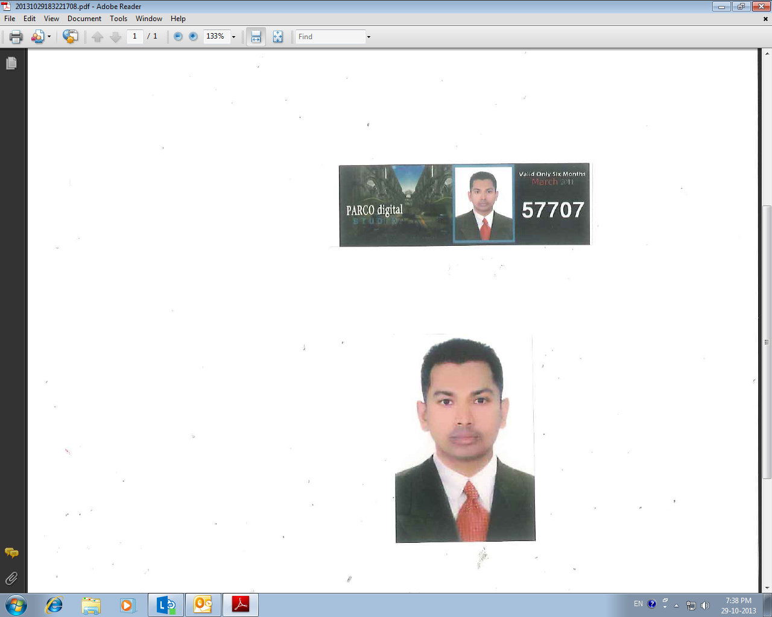
k
rashidmamunur57@yahoo.com +971 55 7423197
Mamunur Rashid
Post Box No: 11417
Dubai, UAE
P

OBJECTIVE
To acquire a professional position in the organization that can offer me a challenging career implementation of skills and will allow growth, personal development and where my efforts in customer service will help in achieving the company’s goal.

EMPLOYMENT HISTORY

Security Guard
Transguard Group LLC
Dubai, UAE

November 2011 – Present
Security Officer
Jumeirah Group
Dubai, UAE

September 2007 – March 2011

EDUCATION

- Higher Secondary Level passed from Bangladesh in 2001

May 2001

OTHER QUALIFICATIONS
- Successfully completed Security Supervisory Training from SIRA.
- Successfully completed DPS Training from Dubai Police Academy.
- Successfully completed a performance coaching workshop.
- Successfully completed a Supervisory creative solutions workshop.
- Successfully completed a Supervisory Delegation Skills workshop.
- Successfully completed a Supervisory Effective Communication workshop.
- Successfully completed a Supervisory Time Management workshop.
- Successfully completed English Intermediate Course.
- Firefighting Training from Dubai civil defence.
- Computer knowledge in MS Excel, MS Word and MS Office.

2018
2017
2016

ACHIEVEMENTS
- Certificate of appreciation 01
- Certificate of appreciation 02
- Certificate of appreciation 03
- Certificate of appreciation 04
- Certificate of appreciation 05
- Certificate of appreciation 06
- Certificate of appreciation 07
- Certificate of Five years’ service.

Certificate of appreciation
Certificate of appreciation

STRENGTH

Fire and Safety traini
I hereby declare that all the above details provided by me are true to the best of my knowledge. I appreciate your time and consideration in reviewing my biodata.

Mamunur Rashid

ACHIEVEMENTS
DECLARATION
English, Hindi & Bengali
LANGUAGE
Sincere, Punctual, Confident, Hard Working & able to work in under pressure.
Playing cricket, Body building and Meeting New People etc.
PERSONAL DETAILS
Date of birth : 24-05-1981

Sex : Male

Marital status : Married

Nationality : Bangladeshi

Passport No : BK 0861684

Religion : Islam

HOBBIES
December 2017
September 2016
August 2015
January 2008.

