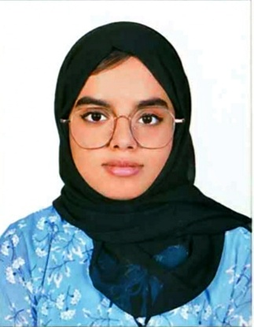  Hasna haneefa  HASNAHANEEFA62@GMAIL.COM  +971568556415  aL Nuaimiyah, AJMAN, uae
  Objective
  Enthusiastic and energetic individual seeking an entry level position that will further develop my skills as a good team player in a retail industry
  lANGUAGES
  ENGLISH
  ARABIC (basic)
  MALAYALAM
  License
  VAlid
  UAE DRIVING LICENSE
  Skills
  - MULTI TASKING ABILITY
  - COMMUNICATION SKILL
  - INVENTORY MANAGEMENT
  - TEAMWORK
  Experience
  SALES MERCHANDISER – ILIFE DIGITAL TECHNOLOGIES LLC
  APR 2021 – JULY 2021
  - Listening to what customers want and helping them find the perfect product for their needs.
  - Constantly building product knowledge and delivering this knowledge in engaging ways.
  - Setting up attractive product displays and promotional booths.
  - Delivering presentations and demonstrations to customers and other stakeholders.
  - Meeting daily targets and submitting sales reports
  - Maximize customer interest and sales levels by displaying products appropriately
  - Managed and kept track of supplies from the supplier
  SHOWROOM ASSISTANT – MARKETING OPERATIONS – ADIDAS HQ
  SEPT 2ND 2020 – NOV 2020
  - Assist shop and showroom clientele in purchases in a manner that maintains long term relationships
  - Manage inventory of shop and showroom
  - Ensured all ordered items were delivered as promised or worked on lead times to satisfy clients
  - Organized and displayed seasonal product samples in a visually appealing manner within the showroom
  - Set up and broke down shelving for displays according to season
  - Ensured all items were labeled with appropriate quote information
  - Assisted buying agents while making selections for their stores.
  SALES merchandiser - adidas
  Sept 2018 to aug 2020
  ajman, SHARJAH, DUBAI
  Supported on the daily operations of back store and in arranging the merchandise on the shop floor.
  - Prioritized and completed wide ranges of tasks each time
  - Managed and tracked supply using company inventory management software
  - Update computer inventory listings
  - Stocked shelves and supplies and organized displays
  - Served customers promptly and knowledgeable
  SALES MERCHANDISER- LENOVO ,
  SHARJAH CITY CENTRE EMAX
  DEC 28TH 2019 TO JAN 31ST 2020 ( DSF PROMO)
  - Listening to what customers want and helping them find the perfect product for their needs.
  - Constantly building product knowledge and delivering this knowledge in engaging ways.
  - Setting up attractive product displays and promotional booths.
  - Delivering presentations and demonstrations to customers and other stakeholders.
  - Meeting daily targets and submitting sales reports
  sales promoter – bsy hair dye
  OCT 2018 – NOV 2018,
  LULU HYPERMARKET, AJMAN
  Demonstrated and explained how the hair dye works to persuade the customers to buy or utilize services.
  - Identified interested and qualified customers in order to provide them with additional information.
  - Sold products being promoted and kept record of sales
  - Suggested specific product purchases to meet customer needs
  - Learned about competitor’s products consumer interest and concerns in order to answer questions and provide more complete information
  Education
  - UNIVERSITY OF THE PEOPLE,
  CALIFORNIA , PASENADA
  (2021 – present)
  - Currently pursuing Bachelors of Science of Business Administration
  - LONDON AMERICAN CITY COLLEGE, SHARJAH
  (2019- 2021)
    - Attended Bachelors of Business Administration (BBA) until second year
    - Achieved a diploma of business administration certification
  - AL AMEER ENGLISH SCHOOL , AJMAN
  ( 2004- 2018)
  - Completed Higher secondary education and achieved 77% in PCMB Science Stream (CBSE Curriculum).

