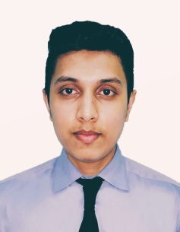
MOHAMED ARSHAD KHAN
Dubai UAE
00971 52 140 2372
Email: arshadkhansaha143@gmail.com

Personal Information
Occupational Interest and Goal
Willing to work in an environment where I can expose myself on a job that can widen my intellect and render my services to the best of my ability. If given the opportunity to work in your company, I will ensure that the trust given to me will not be part in vain. Diligent, responsible, hard-working and determined learner best summarized my attitude towards work.
Educational Attainment:
University / College / School | level of education
IDM Institute - Colombo Sri Lanka | Business Management Diploma, Personal Skill Development, Organization Behavior
UNH International - Colombo | G.C.E. ORDINARY LEVEL
Computer platform - Colombo | Course based on Office 2007, MS Word, Excel. PPM, Lager
Work experience | Currently working on and 6 years of experience in Hospitality industry for Various of Brand Hotels in Dubai UAE.  FMCG modern trade sales 2 years in Sri lanka.
Valid UAE Driving license license no. 4113971

WORK EXPERIENCES:

SENIOR ROOM SUPERVISOR IN EXPO VILLAGE
SENIOR ROOM SUPERVISOR | EXPO VILLAGE | DUBAI - UAE | OCT-2021 | TO DATE



Housekeeping supervisor | PARK REGIS HOTEL BUSINESS BAY (Pre-opening) | DUBAI - UAE | AUG-2019 | OCT 10 2021


Housekeeping supervisor | LAND MARK PREMIUER HOTEL AND SUITS (PRE OPEING) | DUBAI - UAE | Feb-2019 | AUG-2019

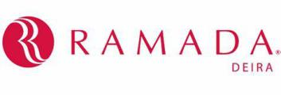

WORK EXPERIENCES:
Housekeeping Supervisor | Ramada Hotel - Deira BY WHYNDAM | DUBAI - UAE | Feb-2018 | Feb-2019

- Allocate work duties to Team Members
- Perform routine inspections of all check out rooms and spot checks of all occupied rooms
- Report and follow up on any maintenance defects or other issues
- Inspect, routinely, service areas, store rooms and corridors
- Schedule and supervise deep cleaning and any other projects
- Manage and train Room Attendants and other Team Members to ensure their performance is to the standards required
- Manage, efficiently, stock control and the maintenance of equipment
- Provide excellent Guest service, including VIP and other special requirements
- Ensure the adherence to hotel brand standards at all times

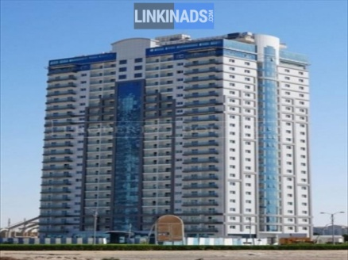
Housekeeping room attendant / team leader | Red Residence Hotel Apartment (PRE-OPENING) | DUBAI – sport city | Aug -2017 | Feb -2018

- Behaves and acts in an exemplary fashion, embodying the brand mindset
- Helps employees improve their skills and provides support for career development
- Manages all floor staff and adapts management practices to suit the brand culture,
- Operational methods, communication, recruitment.
- Guarantees a high standard of service for guests in hotel rooms and common areas in line with hygiene and safety standards
- for improvements or new products or services to meet guest needs


FMCG MODERN TRADE Sales Merchandiser | Fonterra brand | Colombo - Sri Lanka | 16-Jun-2015 | 16 July -2017
- responsible for product
Appearance and supply in various stores throughout their designated area
- Achieve company targets.
- Plan and develop merchandising strategies that balance customers’ expectations and company’s objectives
- analyze sales figures, customers reactions and market trends to anticipate product needs and plan product ranges/stock
- Collaborate with buyers, suppliers, distributors and analysts to negotiate prices, quantities and time-scales
- Maximize customer interest and sales levels by displaying products appropriately
- Produce layout plans for stores and maintain store shelves and inventory
- Forecast profits/sales and plan budgets
- Monitor stock movement and consider markdowns, promotions, price changes, clear outs etc
- Build constructive customer relationships and team with channel partners to build pipeline and close deals
- Remain up to date with industry’s best practice

FMCG MODERN TRADE Sales merchandiser | Hemas brand | Colombo -  Sri Lanka | 1-Dec-2014 | Jun-2015

Soft Skills:
- Having good communication skills (verbal and written )
- Computer literate (word, excel)
- Helpful in nature.
- Ability to resolve problems.
- Ability to work under pressure.
- Having good interpersonal skills.
- Joyful and welcoming nature.
- Versatile
- Hard working and fast learner.
- Willing to undergo training as needed

Name : Mohamed Arshad Khan
Date of birth : July 20th, 1996
Sex : Male
Civil Status : Married
Height : 5’6 ft.
Birthplace : Colombo, Sri Lanka
Address : Dubai, UAE
Contact no : 00971 52 140 2372
Nationality : Sri Lankan / Malay
Driving License : B 3487236
Religion : Islam
UAE driving license : license no. 4113971

REFERANCE

- Mr. Mohamed Saleem
Executive Manager
Red Residence hotel apartment (Dubai- UAE)
TIMES HOTELS (Saudi-KSA)
saleem@beachtimehotels.com
uaedubai.services@gmail.com
00966542100386

- Mr. Hameed Irfan
General manger – RAMADA DEIRA BY WHYNDHAM
Cluster General Manager - land mark group of hotels

- Mrs. Margie
Executive Housekeeper
PARK REGIS HOTEL BUSINESS BAY (DUABI-UAE)
00971509417759

Dear Sir / Madam,

Wish to apply for Suitable Position in your prestige hotel & certify that the above mention vitae given
By me is true & correct to the best of my knowledge.

Thanking You, Yours Truly,

MOHAMED ARSHAD KHAN

