




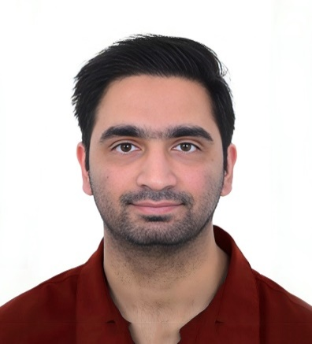
EXPERIENCE
Validation Engineer Mar 2023 – Nov 2023
Mercedes Benz | Sunnyvale, USA
- Spearheaded the analysis of complex test data, successfully pinpointing critical production anomalies.
- Executed validation tests on vehicle components and systems to verify performance and reliability under various operating conditions.
- Conducted validation of processes and equipment according to established protocols and standards.
- Fostered a positive and cooperative work environment by actively collaborating with peers and other staff members.
Service Engineer Aug 2022 – Jan 2023
Cruise | San Francisco, CA, USA
- Verified that hardware and software performance aligned with specified requirements and customer expectations.
- Maintained and updated software versions to ensure systems were running on the latest releases.
- Performed thorough inspections to ensure the proper functioning of hardware components.
- Collaborated closely with developers and engineers to identify recurring issues and implemented preventive measures to reduce incidents.
Engineer Test Technician Jan 2022 – Jun 2022
Apple | Santa Clara, CA, USA
- Ensured achieved &reliable results by meticulously following work instructions and test specifications during service procedures.
- Provided timely updates to test engineers and team leads regarding the status of ongoing testing activities to facilitate efficient workflow management.
- Played a key role in problem-solving efforts by promptly notifying supervisors of production issues and actively participating in the implementation of corrective actions to maintain service efficiency and customer satisfaction.
Process Engineering Technician Jan 2018 - Jan 2021
Tesla | Sparks, NV, United States
- Supported quality standards by recommending and implementing equipment and process modifications.
- Optimized strategies through evaluation and improvement of processes, environment, and material requirements.
- Investigated proposed performance improvements with well-designed laboratory and field tests.
CERTIFICATE
- CCNA
- AutoCAD

PROFILE
Experienced US professional with a background in automotive industry focusing on EV manufacturing and Autonomous Driving R&D. Utilizing over 6 years of experience, adept at driving operational excellence through technical expertise. Proficient in utilizing field related tools & software. Skilled in analyzing test data to identify root causes of production challenges. Dedicated to delivering high-quality solutions and optimizing processes for enhanced efficiency and productivity.
TECHNICAL SKILLS
- JIRA
- Six Sigma Manufacturing
- 3D Printing/Troubleshooting
- THT and SMD soldering
- Project Management
- AutoCAD
+971 562389504
mustafazhafeez@gmail.com
Dubai, UAE
www.linkedin.com/in/mustafa-hafeez
PERSONAL DETAILS
- Language Known: English
- Citizenship: US Citizen
SOFT SKILLS
- Adaptability and Flexibility
- Problem-Solving
- Teamwork and Collaboration
- Communication Skill
- Attention to Detail
- Time Management
- Team Leadership
- Decision Making
EDUCATION
Dec 2017
Bachelor of Science in Electrical Engineering
Iowa State university | Ames, IA, USA

MUSTAFA HAFEEZ
Electrical Engineer | Validation Engineer

