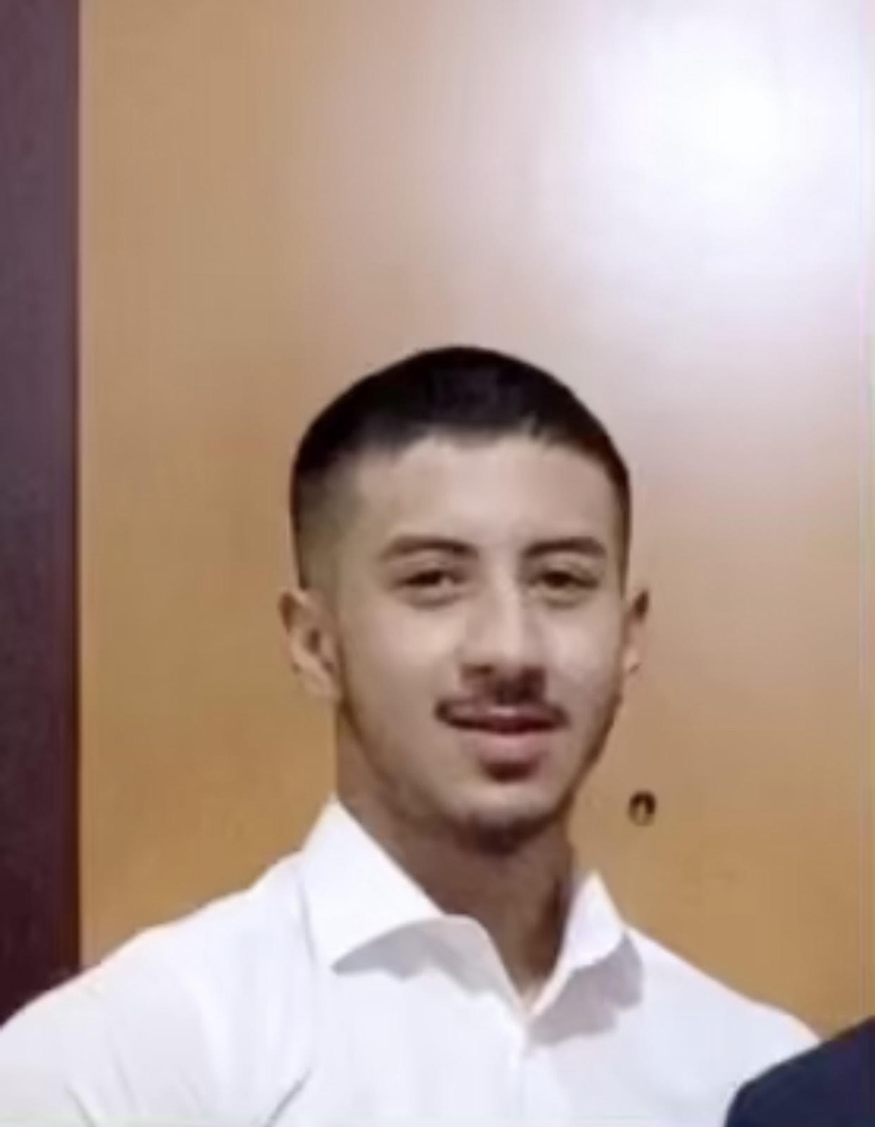 |  | Faisal Maloul
Profile  A student who is pursuing his academic graduation at American University in the emirates with a passion in the field of IT and Cyber Security. Looking for an opportunity to explore work environment and to gain knowledge on this sector or industry so I can have my career path defined.  Contact  PHONE:  0565577565  Instagram  EMAIL:  faisalmaloullive@gmail.com  Hobbies  Swimming  Car shows and events  Enjoy watching movies  Gym  Playing games and listening music |  | EDUCATION  Al Noor International School  American University in The Emirates (AUE)  3rd Semester  IT & Cyber Security  Training & Internship  Completed one month July 2021 month training at Star link Cyber Security - UAE  SKILLS  Communication Skills , Speaking fluent English, Arabic, Hindi and Nepali  Computer Skills , as software professincy  Social Media  Fast Leaner  Team Player  Nationality: Jordanian  Residency Visa : Father sponsorship  Holding UAE driving License  j  Ho

