FUAD C P

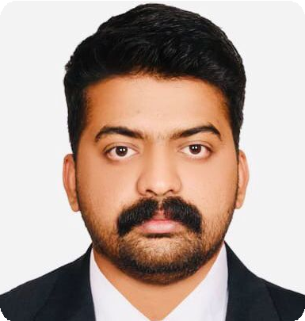

 FUAD C P

 Al Ain , UAE  +971 56 805 7774
fuadmusthafa3@gmail.com

ADMINISTRATIVE PROFESSIONAL

 PROFILE • ABOUT ME
Dynamic and enthusiastic Administrative professional with an overall experience of 5+ Years managing Office Administration, Front Desk Management, Data Entry, Clinical Records Management and General Clerical duties.

Adept at developing and maintaining detailed administrative and procedural processes that reduce redundancy, improve accuracy, and achieve organizational objectives. Skilled at working effectively with different departments to coordinate information and resolve problems.

 CAREER HIGHLIGHTS

 VISA STATUS
Valid UAE Visit Visa

 EDUCATION

Bachelor of Computer Application
University of Calicut

Office Administration Hospital Administration
Data Entry &Record Keeping Documentation & Reporting Office Maintenance

 WORK EXPERIENCE

ADMIN ASSISTANT
HR Assistance Client Relations

Front Desk Management Online/ Digital Documentation Typing & Transcription

May 2021

Kerala, India

Intermediate

Graduated April 2017
SOMERIAN HEALTHCARE & CLINIC
Abu Dhabi
United Arab Emirates

OFFICE ADMIN / DATA ENTRY
- Current

Sep 2017

Government of Kerala Board of Higher Secondary Examination

Kerala, India
CARE WELL CLINIC
Kerala, India

 DUTIES & RESPONSIBILITIES
- Dec 2020

High School
Completed March 2014
Encode patient records and patient results in the clinic information system Extracting relevant information from patient records. Receive and review patient records and supporting documentation for

Government of Kerala General Education Department

Kerala, India
Completed March 2012
Accuracy.
Timely coordination and communication with other clinic staff on records/ results that is insufficient or unclear
Ensuring documents are grammatically correct and free from typing errors Ensure all patient have the appropriate medical coverage for COVID 19 Enter Patient data in EMR
Coordinating office activities and operation to secure efficiency and compliance to policies
Supervising staff and divide responsibilities to ensure performance

 COMPUTER PROFICIENCY

Windows

MS Office

Basic Computer Operations

Data Entry

 SKILLS

Good Communicator Good Clerical Skills
Good Financial Knowledge Time Management Attention to Detail.

Leadership & team Management
Critical & Creative Thinking Pleasing Client Service Planning & Organizing Decision Making

 PERSONAL
INFORMATION

Birthday
26/08/1995

Gender
Male
Marital Status Married Nationality Indian Passport
R6065505
Tracking stock of supplies and place orders when necessary. & submitting timely reports
May schedule or assist in scheduling appointments, meetings, and/or conferences, as appropriate to the position.
May perform specialized services of a routine clerical/administrative nature in strict accordance with established procedural guidelines, as appropriate to the position.
Performs a variety of routine assignments as appropriate to the position; may operate a personal computer to draft basic correspondence, enter data, and print letters, labels, reports, and/or other materials; types and mails form letters.

 PERSONAL INTERESTS
Travel Sports Social Media Music

 LANGUAGES

English

Hindi

Arabic

Malayalam

 VACCINATION STATUS
2 Doses Vaccinated Vaccinated from: UAE

 DECLARATION
I, hereby declare that the information contained herein is true and correct to the best of my knowledge and belief.

FUAD C P AL AIN, UAE

