Contact  Address : Villa 25, Ruqauya Street Abudhabi UAE.  Address: Villa 25, Al Ruqauya Street Abudhbi UAE  Phone : +971 553260822  Email : folly4zeal@yahoo.com.  Skills  - Dedicated, hardworking, positiveattitude, team worker  - Expert in coffee ,tea, milk shakes,Frappes, smoothie,mojito and more.  - Dependable, reliable/responsible  - Energetic  - Integrity  - Self-sufficient  - Financial advising  - Human resources knowledge  - Goal-oriented  - Verbal/written communication  - Organized  - Sales professional  - Customer service  Additional information  Nationality: Nigerian  Marital status: Married  Gender: Female  Visa status: spouse visa  Date of Birth : 21-12-1983  Availability: Immediate
  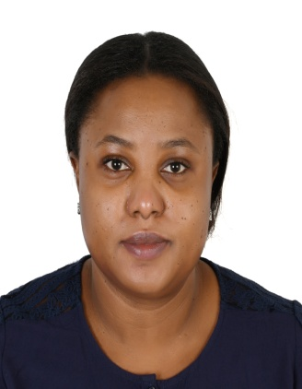
  Folasade Adebakin
  Professional summary
  Driven service-minded professional with over 7 years plus of experience in U.A.E in aspect of operation, customer service, cafe, and restaurant and retail sales. Operation comprise of both front and back of house. Known and recognize for consistently delivering and leading others to excellence, anticipating and responding to guest or customer needs, increasing revenue and retaining loyal customer. Proven capability to manage all aspects of business including quality control, purchasing, financial accounting and reporting. Also to contribute to the success and growth of the company. With an opportunity to a career development.
  Work history
  Branch Supervisor 08/2012 to 03/2020
  Papparoti(Quality brands trading) - Abu Dhabi, United Arab Emirates
  - Coordinate all activities of the store making sure that good service is rendered to the customer always.
  - Taking inventory and preparing all necessary report Making sure that the equipment and facilities for daily operation are in good condition
  - .Ensuring that proper cleaning routine is followed by all staff. Ensuring that all stock is available in the store at all time for a smooth operation.
  - Scheduling of staff shift to meet the demand of the store and following up staff issues and necessity. Liaising with management on ways to improve the standard.
  - Daily monitoring of business performance. Giving instruction on how to improve the business. Introducing creative and positive ideas.
  - Liaising with management on staff requirement and welfare.
  - Assessed employee performance and developed improvement plans.
  - Monitored key performance metrics.
  - Wrote reports detailing branch activities.
  - Met deadlines by proactively managing individual and team.
  - Developed standard operating procedures.
  - Stand in place as barista or any position when need for.
  Head of Department(HOD) 04/2009 to 02/2012
  Vicdel international private school - Lagos, Nigeria
  - Ensure teachers arrive at the right time.
  - Monitor class time table.
  - Ensure that subject for each day is treated.
  - Check and sign of lesson note.
  - Submit daily class report to the proprietor.
  - Ensure that teaching and instructional material are available
  Branch Manager 02/2008 to 09/2008
  Elmolas group of company - Lagos, Nigeria
  - Daily monitoring of business performance.
  - Report directly to the managing director.
  - Introducing creative and positive result
  - Following up staff concern.
  - Taking risk of business and getting positive result.
  - Give room to new idea from colleagues and client.
  - Liaising with management on staff requirement and welfare.
  Education
  Singhania University–( UAE)
  Business Administration, 2020.
  Senior Secondary Education Certificate–(2000) Lagos Nigeria.
  Accomplishments
  - Computer Proficiency - Microsoft office and internet explorer
  Certifications
  Ordinary online certificate: Sociology, Entrepreneurship and family business.(2017).
  ADFCA certificate(2014)
.

